Name ________________________________________
Protestantism Spreads hw
- Why was King Henry VIII given the title “Defender of the Faith?”

- Explain his issue with his wife, Catherine of Aragon.

- Act of Supremacy-

- When Henry died, his 3 children ruled England in turn. Explain the religious significance of each of Henry VIII’s children when they ruled. (What religion were they and what changes were made religiously during their rule?)
Edward-

Mary-

Elizabeth-

- List 2 characteristics of the Anglican Church.

- Who was John Calvin?

- Predestination-

- Jesuits-

- Explain the following teachings that were decided at the Council of Trent:
Interpretation Bible-

Salvation-

Bible & Church Traditions-

Indulgences-

- What was the Index of Forbidden Books?

The Reformation Spreads
The Church of England
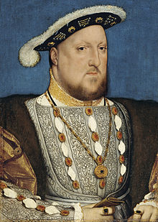
When Henry VIII became king of England in 1509, he was a devout Catholic. Indeed, in 1521, Henry wrote a stinging attack on Luther’s ideas. In recognition of Henry’s support, the pope gave him the title “Defender of the Faith.” Political needs, however, soon tested his religious loyalty. He needed a male heir. Henry’s father had become king after a long civil war. Henry feared that a similar war would start if he died without a son as his heir. He and his wife, Catherine of Aragon, had one living child—a daughter, Mary—but no woman had ever successfully claimed the English throne.
By 1527, Henry was convinced that the 42-year-old Catherine would have no more children. He wanted to divorce her and take a younger queen. Church law did not allow divorce. However, the pope could annul, or declare invalid, Henry’s marriage if proof could be found that it had never been legal in the first place. In 1527, Henry asked the pope to annul his marriage, but the pope turned him down.
Henry took steps to solve his marriage problem himself. In 1529, he called Parliament into session and asked it to pass a set of laws that ended the pope’s power in England. This Parliament is known as the Reformation Parliament. In 1533, Henry secretly married Anne Boleyn, who was in her twenties. Shortly after, Parliament legalized Henry’s divorce from Catherine. In 1534, Henry’s break with the pope was completed when Parliament voted to approve the Act of Supremacy. This called on people to accept Henry, not the pope, as the official head of England’s Church.
Henry did not immediately get the male heir he sought. After Anne Boleyn gave birth to a daughter, Elizabeth, she fell out of Henry’s favor. Eventually, she was charged with treason. She was imprisoned in the Tower of London. She was found guilty and beheaded in 1536. Almost at once, Henry took a third wife, Jane Seymour. In 1537, she gave him a son named Edward. Henry’s happiness was tempered by his wife’s death just two weeks later. Henry married three more times. None of these marriages, however, produced children.
After Henry’s death in 1547, each of his three children ruled England in turn. This created religious turmoil. Henry’s son, Edward, became king when he was just nine years old. Too young to rule alone, Edward VI was guided by adult advisers. These men were devout Protestants, and they introduced Protestant reforms to the English Church. Almost constantly in ill health, Edward reigned for just six years. Mary, the daughter of Catherine of Aragon, took the throne in 1553. She was a Catholic who returned the English Church to the rule of the pope. Her efforts met with considerable resistance, and she had many Protestants executed. When Mary died in 1558, Elizabeth, Anne Boleyn’s daughter, inherited the throne.
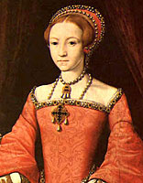
Elizabeth I was determined to return her kingdom to Protestantism. In 1559, Parliament followed Elizabeth’s wishes and set up the Church of England, or Anglican Church, with Elizabeth as its head. This was to be the only legal church in England. Elizabeth decided to establish a state church that moderate Catholics and moderate Protestants might both accept.
Characteristics of the Anglican Church
The Anglican faith is often considered a reformed Catholicism, a hybrid between the Catholic and Protestant faiths. Anglicans base their Christian faith on the Bible, traditions of the Church, and writings of the Church Fathers. Unique to Anglicanism is the Book of Common Prayer, the collection of services that worshippers in most Anglican churches have used for centuries verses the Lutherans’ worship guide is the Book of Concord. Lutherans and Anglicans both deny purgatory and affirm eternal hell. Anglican priests can marry, and there is no monasticism. The Episcopal Church is the American church in the Anglican Communion.

Calvinism
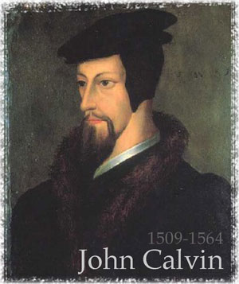
In 1536, John Calvin published Institutes of the Christian Religion. This book expressed ideas about God, salvation, and human nature. It was a summary of Protestant theology, or religious beliefs. Calvin wrote that men and women are sinful by nature. Taking Luther’s idea that humans cannot earn salvation, Calvin went on to say that God chooses a very few people to save. Calvin called these few the “elect.” He believed that God has known since the beginning of time who will be saved. This doctrine is called predestination. The religion based on Calvin’s teachings is called Calvinism. One admirer of Calvinism was a Scottish preacher named John Knox. When he returned to Scotland he made Calvinism Scotland’s official religion. Followers of Knox became known as Presbyterians.

The Catholic Reformation
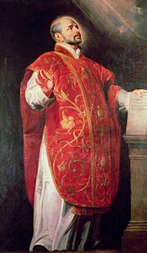
While Protestant churches won many followers, millions remained true to Catholicism. Helping Catholics to remain loyal was a movement within the Catholic Church to reform itself. This movement is now known as the Catholic Reformation. Historians once referred to it as the Counter Reformation.
Ignatius of Loyola Ignatius grew up in his father’s castle in Loyola, Spain. The great turning point in his life came in 1521 when he was injured in a war. While recovering, he thought about his past sins and about the life of Jesus. His daily devotions, he believed, cleansed his soul. In 1522, Ignatius began writing a book called Spiritual Exercises that laid out a day-by-day plan of meditation, prayer, and study.
Jesuits
For the next 18 years, Ignatius gathered followers. In 1540, the pope created a religious order for his followers called the Society of Jesus. Members were called Jesuits. The Jesuits focused on three activities. First, they founded schools throughout Europe. Jesuit teachers were well-trained in both classical studies and theology. The Jesuits’ second mission was to convert non-Christians to Catholicism. So they sent out missionaries around the world. Their third goal was to stop the spread of Protestantism.
Reforming Pope
Pope Paul III, pope from 1534 to 1549, took four important steps to reform the Catholic Church. First, he directed a council of cardinals to investigate indulgence selling and other abuses in the Church. Second, he approved the Jesuit order. Third, he used the Inquisition to seek out heresy in papal territory. Fourth, and most important, he called a council of Church leaders to meet in Trent, in northern Italy.
Council of Trent
From 1545 to 1563, at the Council of Trent, Catholic bishops and cardinals agreed on several doctrines:
- The Church’s interpretation of the Bible was final. Any Christian who substituted his or her own interpretation was a heretic.
- Christians needed faith and good works for salvation. They were not saved by faith alone, as Luther argued.
- The Bible and Church tradition were equally powerful authorities for guiding Christian life.
- Indulgences were valid expressions of faith. But the false selling of indulgences was banned.

Beck, Roger B. World History: Patterns of Interaction. Evanston, IL: McDougal Littell, 2005. Print.

