McCarthyism—Red Scare
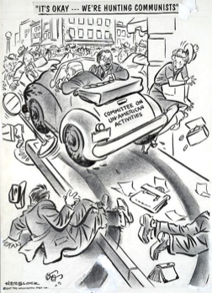
Document 1
“Its Okay, We’re Hunting Communists” By Herbert Block, Oct 31, 1947 Washington Post
- What is happening in the cartoon?

- How does the House Committee on Un- American Activities (HUAC) car parallel HUAC activities of the time?

- How are people affected by the HUAC car in the cartoon?

- What do you think is the author's attitude toward HUAC?

Document 2
“One communist, one communist in the faculty of one university is one communist too many. One communist among the American advisors at Yalta was one communist too many. And even...even if there were only one communist in the State Department, even if there were only one communist in the State Department that would still be one communist too many.”

"One Communist" By Senator Joseph McCarthy, July 7, 1952

- What is the assumption regarding the result of having “one Communist” in any of the situations the author lists?

- Who are the intended audiences for this speech (not necessarily who he is speaking to at the time of the speech, but who might he hope to get a response from)?

- What type of response is McCarthy likely to get from this portion of his speech?

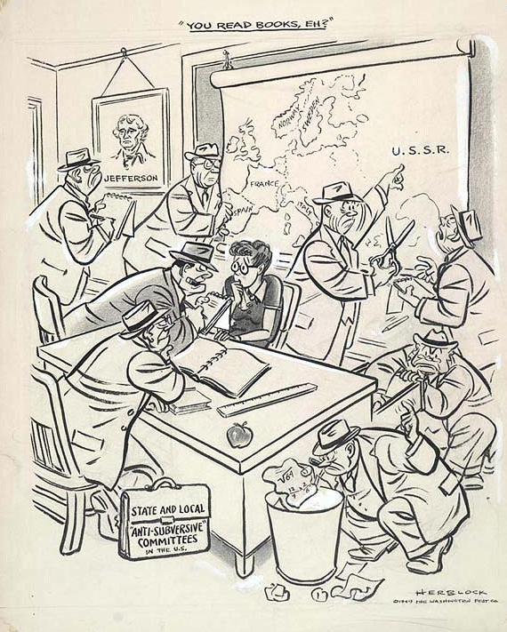
Document 3
“You Read Books, Eh?” By Herbert Block, April 24, 1949 Washington Post
- What are the men in the cartoon doing (collectively)?

- What animal do many of the men look like? Is there any significance to this?

- What evidence are the men finding that they might use against the teacher?

- What is being ridiculed in this cartoon?

Document 4
“How Communism Works" Source: Catholic Library Services, 1938
- Who might the Octopus represent?

- Why did the author choose an octopus as the symbol for communism in this poster?

- What is the message of this poster?

- Who paid for the production of this poster and why is that important?

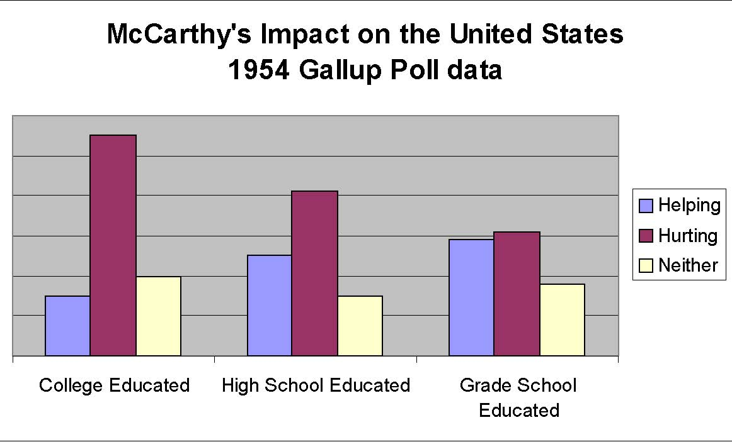
Document 5
Response to the following question asked of those who heard about McCarthy’s accusations: Some people say these charges are doing the country more harm than good. What do you think?
- Does this poll suggest that people in the US are more likely support or oppose Senator McCarthy’s actions?

- What is the implication of education level on one’s opinion of McCarthy’s accusations?

- What would you guess is the thinking behind people who answered “neither”?

Document 6
Walt Disney’s Testimony to HUAC, In his testimony to the House Un-American Activities Committee (HUAC), Disney discusses the effect that he believes communists have had on his employees, who had recently unionized and gone on strike.

SMITH: Do you have any people in your studio at the present time that you believe are communist or fascist, employed there?
DISNEY: No; at the present time I feel that everybody in my studio is 100 percent American.
SMITH: Have you had at any time, in your opinion, in the past, have you at any time in the past had any communists employed at your studio?
DISNEY: Yes; in the past I had some people that I definitely feel were communists.
SMITH: As a matter of fact, Mr. Disney, you experienced a strike at your studio, did you not?
DISNEY: Yes.
SMITH: And is it your opinion that that strike was instituted by members of the Communist Party to serve their purposes?
DISNEY: Well, it proved itself so with time, and I definitely feel it was a communist group trying to take over my artists and they did take them over.
CHAIRMAN: Do you say they did take them over? DISNEY: They did take them over.

- According to the testimony above, how had communists affected Walt Disney’s studios?

- Was any evidence presented to support the accusations in this statement?

