Name ______________________________________________________
Treaty of Versailles Reactions
Source: Count von Brockdorff-Rantzau, leader of the German Peace Delegation. Letter written to Paris Peace Conference President Georges Clemenceau about the Treaty of Versailles, May 1919. [He makes several counter-proposals to the treaty to attempt to make what he feels is a more fair peace proposal. In the end, he resigned over the signing of the treaty.]

Mr. President:
…We came to Versailles in the expectation of receiving a peace proposal based on the agreed principles. We were firmly resolved to do everything in our power with a view of fulfilling the grave obligations which we had undertaken… We were aghast when we read in documents the demands made upon us, the victorious violence of our enemies. The more deeply we penetrate into the spirit of this treaty, the more convinced we become of the impossibility of carrying it out. The exactions of this treaty are more than the German people can bear…
Counter-proposals…
9. The German delegation again makes its demand for a neutral inquiry into the responsibility for the war... An impartial commission should have the right to investigate on its own responsibility the archives of all the belligerent [aggressive] countries and all the persons who took an important part in the war. Nothing short of confidence that the question of guilt will be examined dispassionately [rationally] can leave the peoples lately at war with each other in the proper frame of mind for the formation of the League of Nations…
Document 1
- What was the expectation that von Brockdorff-Rantzau had about what peace would look like when Germany surrendered?

- What was his (the German) reaction to the treaty?

List 3 TONE words that exemplify how he felt.

- The most shocking element of the treaty to Germany was the total blame Germany had to bare for the responsibility for the war. What does von Brockdorff-Rantzau propose in response to this element of the treaty?

Source: Georges Clemenceau's Letter of Reply to the Objections of the German Peace Delegation, May 1919 [Clemenceau was the French Prime Minister during WWI who demanded total victory over Germany.]

Sir:
… The protest of the German Delegation shows that they utterly fail to understand the position in which Germany stands today. They seem to think that Germany has only to "make sacrifices in order to attain peace," as if this were but the end of some mere struggle for territory and power… In the view of the Allied and Associated Powers the war which began on August 1, 1914, was the greatest crime against humanity and the freedom of peoples that any nation, calling itself civilized, has ever consciously committed.
For many years the rulers of Germany… strove for a position of dominance in Europe. They were not satisfied with that growing prosperity and influence to which Germany was entitled …
Germany's responsibility, however, is not confined to having planned and started the war. She is no less responsible for the savage and inhuman manner in which it was conducted… They were the first to use poisonous gas, notwithstanding the appalling suffering it entailed. They began the bombing and long distance shelling of towns for no military object, but solely for the purpose of reducing the morale of their opponents by striking at their women and children. They commenced the submarine campaign with its piratical challenge to international law, and its destruction of great numbers of innocent passengers and sailors…The conduct of Germany is almost unexampled in human history.
Document 2
- Name THREE ways that Germany conducted war in WWI that Clemenceau was protesting.

Document 3
Source: Sir Eric Geddes, December 1918. Speech given in front of large crowd at a re-election rally. [Geddes was Minister of Munitions in Britain, Controller of the Navy and First Lord of the Admiralty.]

“The Germans…are going to pay every penny; they are going to be squeezed, as a lemon is squeezed, until the pips squeak. My only doubt is not whether we can squeeze hard enough, but whether there is enough juice. (Laughter.) It is right that they should pay. They brought this war on; they asked for it, and they have got it. And now let them pay the bill for the goods they have asked for. (Applause.)
- What is Geddes talking about in this portion of his speech?

- Why do you think Geddes, as British, responded this way to Germany at the end of WWI?

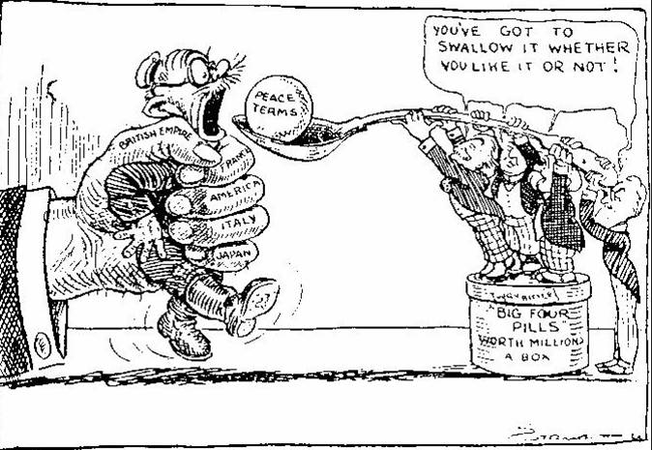
Document 4

Cartoon in British newspaper 1919

- What is occurring in Document 4? Describe and analyze the political cartoon.

Document 5
Source: Deutsche Zeitung [The German Express] newspaper, June 28, 1919

Vengeance! German Nation
Today in the Hall of Mirrors, the disgraceful Treaty is being signed. Do not forget it. The German people will with unceasing labour press forward to reconquer the place among nations to which it is entitled. Then will come vengeance for the shame of 1919.
- Based on the newspaper above, how did most Germans felt about the Treaty of Versailles? Why?

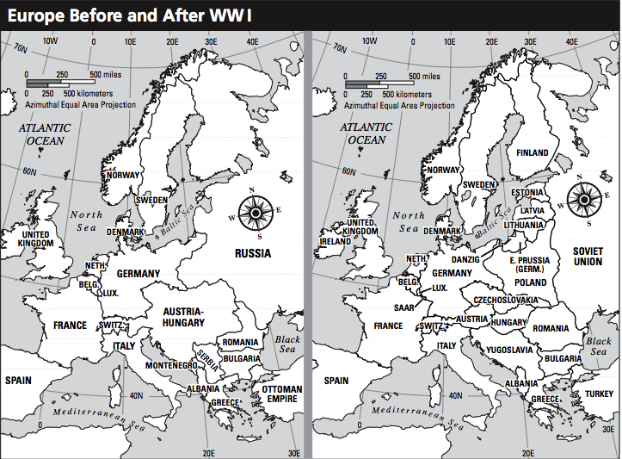
Post WWI Map Analysis:
- What NEW nations were created after WWI?

- What happened to the nation of Austria-Hungary?

- Color Germany on both maps. (hint: Germany is 1 large nation on the before WWI map. On the after WWI map Germany is split up—East Prussia is also part of Germany—color both.)

