Southeast Asian States
Fill in the chart based on the readings.
 | Politics | Religion | Economics
Sea Based Kingdoms:
Srivijaya Empire (Sumatra)
Majapahit (Java)

Land Based Kingdoms:
Khmer Empire [a.k.a. Angkor] (Cambodia)

Sukhothai Kingdom (Thailand)

South Asian States
 | Politics | Religion | Economics
Vijayanagava Empire

Delhi Sultanate

Key Terms: (use the internet to define/explain the following)
Caste System-

Urdu- (what is it, where spoken? How an example of syncretism?)

Bhakti Movement-
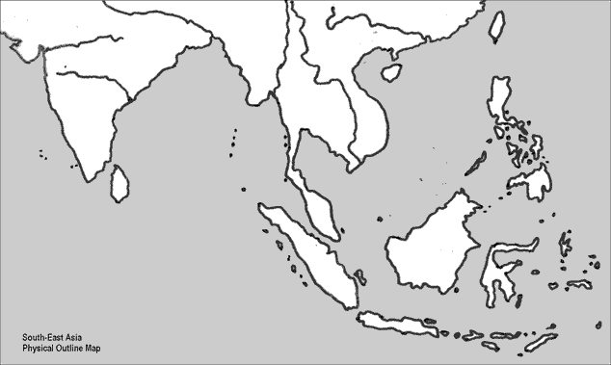
Color and label each of the kingdoms on the map below. Also label: Malacca Strait, Sundra Strait, and Indian Ocean

What is the connection between the Indian Ocean trade and Southeast Asian state formation?

