Name __________________________________________________
Africa Webquest
Part 1—War in Sudan
Since Sudan gained its independence from Britain in 1956, there have been major struggles between the Afro-Arabs in north and the black Christians in the south. Civil War (1983-2005) Civil War in Darfur (2003-today)
http://www.washingtonpost.com/wp-srv/world/interactives/sudan/
Using the website above to answer the following questions.
- The conflict in Sudan have had a negative influence on the nation. It has made Sudan the world’s most ___________ nation for 2 years in a row.
- On the map key, click the box that says “oil production.” Where are most of them located? How do you think this has impacted the war?

- Click “more.” Find the green box in top left corner titled “Darfur Crisis”—click “more.” View the pictures. Describe 3 images that struck you the most.

Part 2—AIDS in Africa
http://www.avert.org/hiv-aids-sub-saharan-africa.htm
Use the website above to answer the following questions.
- _________________________________________ (area) has the most serious HIV and AIDS epidemics in the world. They account for nearly ___% of the global total.

- List at least 5 nations that have high HIV prevalence.

- Why is HIV more widespread in Africa than elsewhere in the world, and why are some parts of Africa affected more than others? (ask me about this—I will put the answer on the projector)

- Read “HIV prevention programmes in East and Southern Africa.” Find the blue box labeled: Case study: DREAMS. Explain the U.S.’s program called DREAM.

- Scroll down and read “Barriers to HIV Prevention in East and Southern Africa.” (it will be in blue) What are some of these barriers? Explain them.

Part 3—Apartheid South Africa
http://docs.wixstatic.com/ugd/921c0a_a94cdcc2061d46e988e6f6a5aecf7019.pdf
Use the website above to answer the following questions.
- Look at the laws regarding education. Summarize what you read about the education laws for Black South Africans.

- Read 1950 Act 137. What are your thoughts about this law?

- What law shocked you the most? Why?

- How do you think you would have reacted if you lived in South Africa during this time period? How do you think the people of South Africa felt about them?

Part 4—Genocide Map
Using the internet, define genocide-

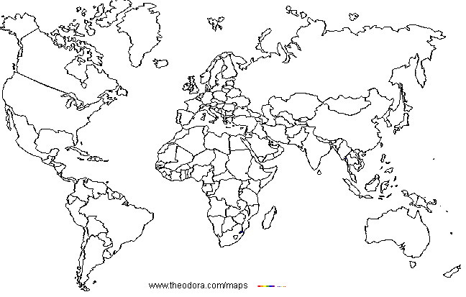
Research using the internet and find 3 regions of the world (anywhere, not just Africa) where genocide is occurring today. Label the region, explain the genocide, and color the region on the map.
Part 5: Political Cartoon
Draw a political cartoon representing one of the major events you read about in Africa today (Darfur/Sudan, AIDS pandemic, South African Apartheid). It must be colored.

