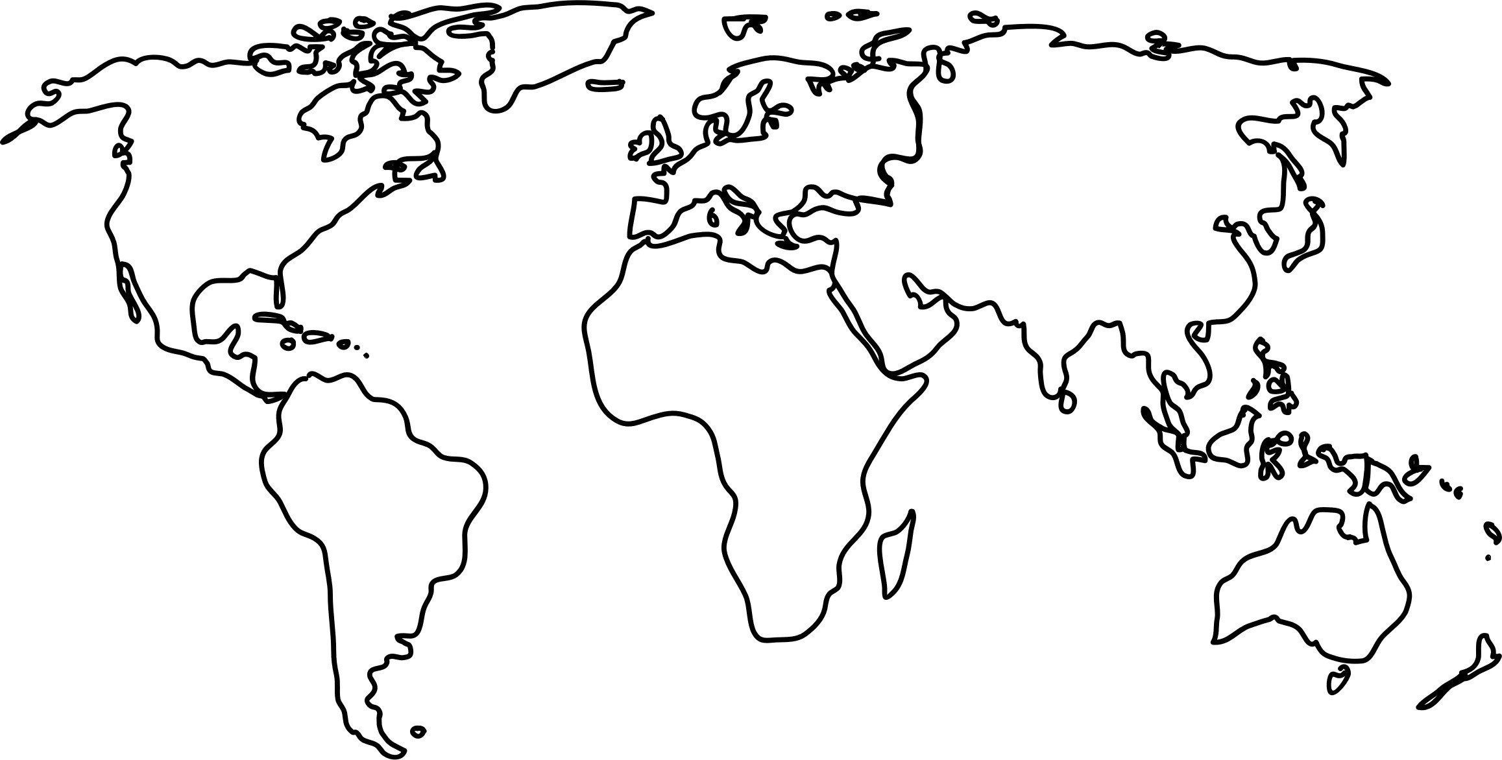
-Turn Over-
Name _____________________________
Columbian Exchange Map
Summary Questions

Part 1: Disease Diffusion
- Who is the “loser” in the “Disease Diffusion” game? Why?

- Why do you think the Americas had so many diseases transmitted to them?

Part 2: Animal and Crop Diffusion
- What impact do you think the horse has on the “New World”?

- Why do you think so few animals “diffused” from the Americas to Europe?

- In your opinion, what are the 2 most important crops “diffused” from the Americas to Europe?

Part 3: Silver Diffusion
- What does the movement or diffusion of silver from each of these areas to another tell you?

Part 4: Slave Trade
- Do some quick math: what percentage of all slaves went to Central America?

- What percentage went to “South America”?

Overview:
- Why is the Columbian Exchange called a "tsunami of biological exchange”?

- Give two examples of how the Columbian exchange has affected your life?

- How did the introduction of slaves from Africa, into the Americas effect Native American and European cultures in your opinion?

