Name ______________________________________________
The Renaissance Begins Hw

Answer the following questions based on the reading below.

- Why did the Renaissance begin in Italy? (be specific and give SEVERAL reasons!)

Define the following terms:
- Renaissance-

- humanism-

- secular-

- vernacular-

- patron-

- Renaissance Man-

- Renaissance Woman-

Identify the following people and explain fully why they are significant to the Renaissance.
- Medici-

- Petarch-

Renaissance Begins
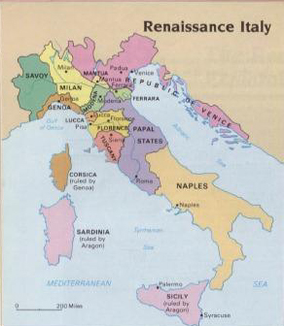
The Renaissance was the period from about 1350 until 1600 during which western Europeans experienced a profound cultural awakening. It also signaled the beginning of modern times. The word Renaissance literally means “rebirth” and was coined to refer to the rebirth of interest in classical ideas and culture.

Why the Renaissance Began in Italy
The Renaissance began first in the city-states of Italy. Unlike other areas of Europe, Italy had largely avoided the economic crisis of the late Middle Ages. Italian towns remained important centers of Mediterranean trade and boosted their production of textiles and luxury goods.
More than any other Europeans, Italians were attached to classical traditions. The ruins of ancient Roman buildings, arches, and amphitheaters constantly reminded them of their heritage. Moreover, through trade Italian towns remained in close contact with the Byzantine Empire, where scholars preserved the learning of ancient Greece.
The Renaissance is generally considered to have started in Florence, Italy around the years 1350 to 1400. The start of the Renaissance also was the end of the Middle Ages.
Humanism
Through renewed contact with the classics, Italian scholars improved their understanding of Greek and Latin, studied old manuscripts, and copied the classical writing style. This interest in classical learning, however, was more than just a fascination with ancient times. It led to a new intellectual movement known as humanism that focused on secular, or worldly, themes rather than on the religious ideas that had concerned medieval thinkers. Humanism—the scholars who promoted humanism—accepted classical beliefs and wanted to use them to renew their own society. Among the most important beliefs was individualism, an emphasis on the dignity and worth of the individual person. Another was the idea of human improvement, that people should develop their talents through many activities: politics, sports, and the arts.
Humanists believed that education could help people improve themselves. They opened schools that taught the studia humanitas, or humanities—Greek, Latin, history, and philosophy, the subjects taught in ancient times. These schools became so popular that humanists began to replace the clergy as teachers of the sons of the wealthy.
Humanism also inspired new forms of literature written in the vernacular, native language, and focusing on personal feelings.
Petrarch and Humanism
Francesco Petrarch is often called the "Father of Humanism". He was a scholar and a poet who lived in Florence in the 1300s. He studied poets and philosophers from Ancient Rome such as Cicero and Virgil. His ideas and poetry became an inspiration to many writers and poets throughout all of Europe as the Renaissance spread.
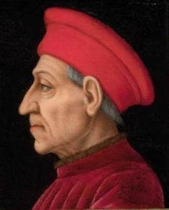
Florence, Italy
At the start of the Renaissance, Italy was divided up into a number of powerful city-states. These were areas of land that were ruled by a large city. Each city-state had its own government. One of the major city-states was Florence. The government that ran Florence was a republic, like ancient Rome. This meant that the citizens elected their own leaders.
In the late 1300s, Florence had become a rich city. Wealthy merchants and businessmen had the money to hire artisans and craftspeople. These wealthy individuals who provided financial support to scholars, painters, sculptors, poets, and/or architects were called patrons. This inspired competitions among artists and thinkers. Art began to flourish and new thoughts began to emerge.
In the 1400's the Medici family came into power in Florence. They were wealthy bankers and helped the arts along by sponsoring many artists and using their personal funds to further the humanist movement.

New Ideas Spread
This new way of thinking and style of art quickly spread to other wealthy Italian city-states such as Rome, Venice, and Milan. This early part of the Renaissance is often called the Italian Renaissance. Italy would become wealthy through trade and their new ideas soon spread throughout all of Europe.

Renaissance Man and Woman
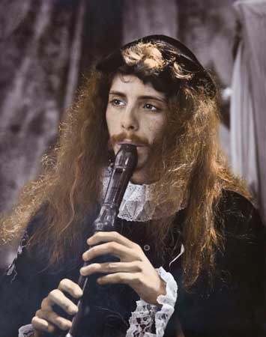
A Renaissance man or polymath is a person who is skilled in multiple fields or multiple disciplines, and who has a broad base of knowledge. The term renaissance man is largely based on the various artists and scholars of the European Renaissance, (starting in about 1450 CE), who pursued multiple fields of studies. Perhaps the quintessential renaissance man of this period was Leonardo Da Vinci, who was a master of art, an engineer, an anatomy expert (for the time), and also pursued many other disciplines with great success. Humanists were ambivalent about the education for women. A Renaissance women was still restricted to domestic spheres and did not establish schools for girls.

