Napoleon—He’s Baaaack!—Or Is He?
Using your notes and the reading answer the following:
- Goals of the French Revolution (at least 4)

- Napoleon’s positive accomplishments for France: (at least 4)

- Napoleon’s failures: (at least 4)

In 1814, the Forth Coalition (major European powers) took Napoleon from power. Louis XVIII, the brother of Louis XVI, issued a manifesto in which he promised to recognize some of the results of the Revolution if he was made king of France. When the European armies entered Paris in March 1814, a negotiation was made for the restoration of the monarchy.
On May 2, King Louis XVIII officially promised a constitutional monarchy with a bicameral parliament, religious toleration, and constitutional rights for all citizens. The resulting Charte Constitutionnelle was adopted on June 4, 1814.
But…there is a possibility that Napoleon Bonaparte could escape from exile on Elba Island! Some Frenchmen still support Napoleon, while others do not.
You are living in France in 1815. You and your committee must decide if you would welcome Napoleon Bonaparte back as the leader of France.
This MUST be an educated decision among your committee, so discuss the elements below with your committee before you reach a decision.
- Characteristics of a good leader:

 | Advantages (politically, economically, socially, internationally) | Disadvantages (politically, economically, socially, internationally)
Under Napoleon’s leadership again

Under a king’s leadership again

Your decision: I ______________________________ (would OR would not) accept Napoleon back as the ruler of France.

Defend your decision:

Napoleon’s Legacy
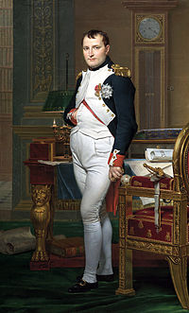
Positive Impact
- Napoleonic Code
  - Before this code, many feudal and royal laws in France were contradictory in some cases and confusing for people
  - Expanded the right to own property
  - Many countries adopted almost identical codes
  - Law much more clear and accessible
  - Elimination of exemptions and privileges
- Centralized French government
- Expanded suffrage rights (though they were still limited)
- Greater property rights for French citizens
- Expanded education for many French citizens
- Introduced the Metric system to France
Negative Impacts
- Left France bankrupt, and her overseas colonies lost
- 17 years of wars
- 6 million people dead throughout Europe
- Got rid of the French Republic
- Considered a tyrant by many Frenchmen
- Strict censorship, controlling aspect of the press, books, theater, and art

On the one hand, Napoleon's policies created the foundation for much of France's legal and social system today. For instance, the Code Napoleon is the French civil code. It forbids privileges based on birth and allows freedom of religion among other things. Napoleon's efforts to emancipate the Jews of France and allow them to leave the ghettos to which they were previously constrained also represents an important advance. Politically, those who view Napoleon in a favorable light would argue that he put an end to a period of lawlessness and chaos in France.
Critics of Napoleon insist that his ultimate legacy was bankruptcy and territorial losses for France. France's colonial losses during the period of Napoleon's rule are viewed to have weakened it significantly. Napoleon also restored slavery in France's overseas colonies. Finally, his wars are estimated to have caused millions of military and civilian deaths in France and Europe.

Napoleon’s Legacy in France today:
Napoleon is generally viewed in a favorable light, if only because so many monuments and landmarks in France still bear his mark. To give a few examples, the boulevards surrounding Paris are named after Napoleon's marshals, the Arc de Triomphe is a tribute to his victories and the Place de la Concorde a tribute to his conquest of Egypt. He is buried in the Invalides, one of the most recognizable and opulent buildings in Paris. Many prominent streets are named after his military victories.
That said, there is some ambiguity with regard to commemorating Napoleon. The 200th anniversary of the great victory of the Battle of Austerlitz was not officially celebrated in 2005 (the Brits, however, certainly celebrated the anniversary of Trafalgar a year before that).
Ultimately, though he is not celebrated as a national hero, Napoleon is remembered in a fairly positive light in the minds of the French people, and that his imprint on modern France is unavoidable.

Europe pre-French Revolution
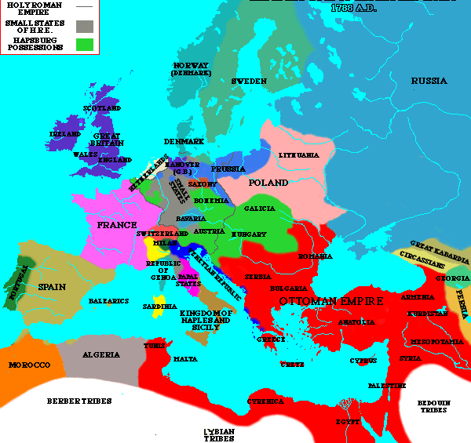

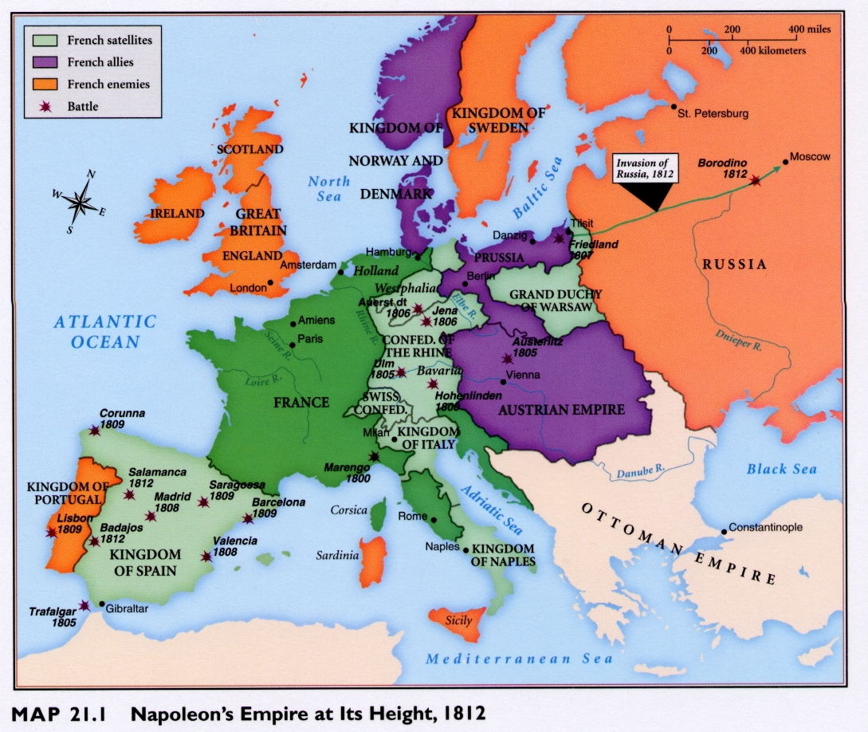
Napoleon’s Empire—1812

