WH Research Paper Notecard Directions
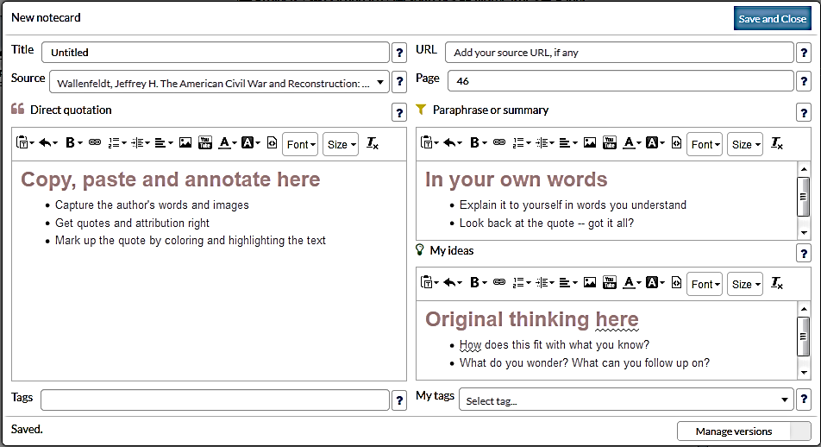
Requirements for Each Notecard
- Give each a Title—each notecard should have a unique title (no repeats and no calling them “background 1” and “background 2”).
- Click on your source. (Do NOT forget to do this!)
- Either QUOTE or PARAPHRASE
- (no need to do both—you can skip the “Original thinking here” section)
Paraphrase
Quote
- Quote:
  - ONLY 5 quotes allowed out of all 65 notecards!
  - Quotes should be 2-4 sentences long.
- Paraphrase:
  - Please use bullet points if you are paraphrasing.
  - Only 2-4 sentences long or 2-5 bullet points
- If it is from a print source or Ebook, put the page number.
- Hit “Save and Close”

Groups/Piles:
- Once you get several notecards made, please start putting them in groups/piles to organize them.
- A good way to organize your groups/piles is according to the main points of your thesis.
- Give each group/pile and original name—should not be the same as the name of any notecards.

WH Research Paper Notecard Directions
Requirements for Each Notecard
- Give each a Title—each notecard should have a unique title (no repeats and no calling them “background 1” and “background 2”).
- Click on your source. (Do NOT forget to do this!)
- Either QUOTE or PARAPHRASE
- (no need to do both—you can skip the “Original thinking here” section)
Paraphrase
Quote
- Quote:
  - ONLY 5 quotes allowed out of all 65 notecards!
  - Quotes should be 2-4 sentences long.
- Paraphrase:
  - Please use bullet points if you are paraphrasing.
  - Only 2-4 sentences long or 2-5 bullet points
- If it is from a print source or Ebook, put the page number.
- Hit “Save and Close”

Groups/Piles:
- Once you get several notecards made, please start putting them in groups/piles to organize them.
- A good way to organize your groups/piles is according to the main points of your thesis.
- Give each group/pile and original name—should not be the same as the name of any notecards.

