Imperialism in Latin America
- What was the Monroe Doctrine?

It was created in the year ___________.
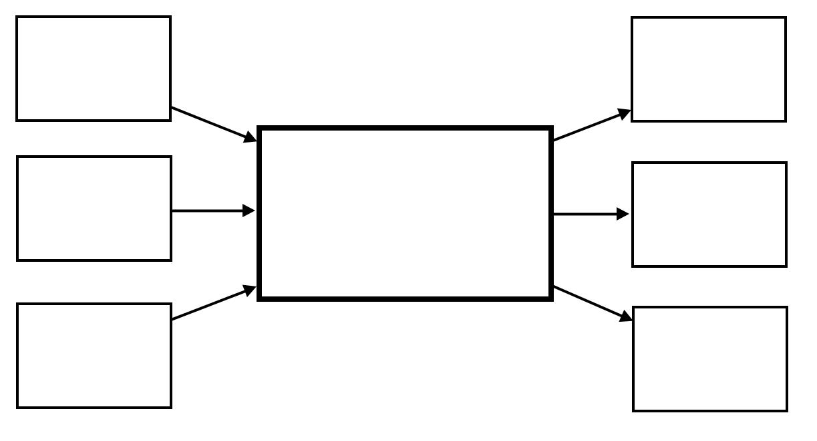
- After Puerto Rico went to the United States, was it given independence OR statehood? Explain your answer.

- Discuss Puerto Ricans’’ status within the U.S. today.

What do you feel should happen to Puerto Rico today?

- Explain the major principles of the Platt Amendment.
U.S.
Imperialism

- President Theodore Roosevelt added the to the Monroe Doctrine. What did the Roosevelt Corollary say?

- Roosevelt’s “big stick” was ___________________.
- How did Latin American nations feel about the Roosevelt Corollary (“Big Stick Policy”)?

- Why did the United States get involved in Panama’s independence from Columbia?

- Describe the difficulties building the Panama Canal.

