Greece Map

Use the map on:
- page 80 in your textbook\

1. Label the following areas:
- Crete
- Macedonia (might be called Macedon in textbook)
- Anatolia (might be called Asia Minor in textbook)

2. Label and color BLUE the following bodies of water:
- Ionian Sea - Mediterranean Sea - Aegean Sea

3. Cities:
- Athens - Sparta - Troy (on other side of Aegean Sea)
- Corinth - Marathon

4. Shade GREEN and make a key for the area of the Greek homeland.

6. Title the map “Ancient Greece.”
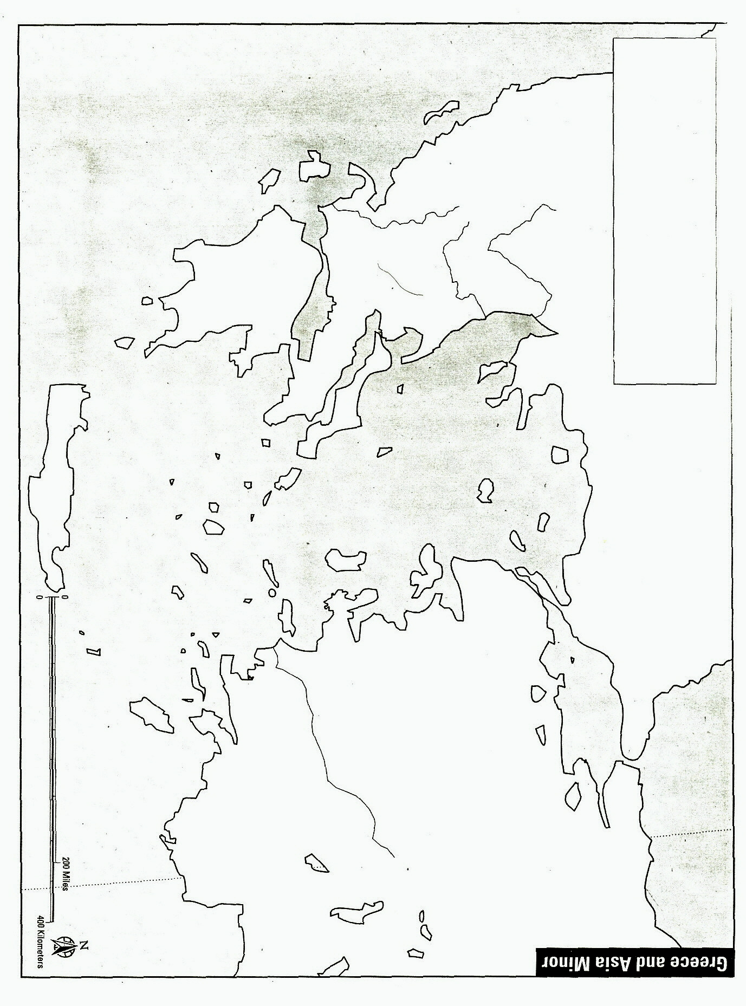
- page 80 in your textbook (A History of World Societies—blue book)
Name ____________________________________________________
Title:____________________________________________________
Key:
- 3rd period: page 128 in class set books (The Earth and Its Peoples—white book)
- 4th & 5th periods: page 114, 121, 124 in class set of books (World History: The Human Experience—red book)

