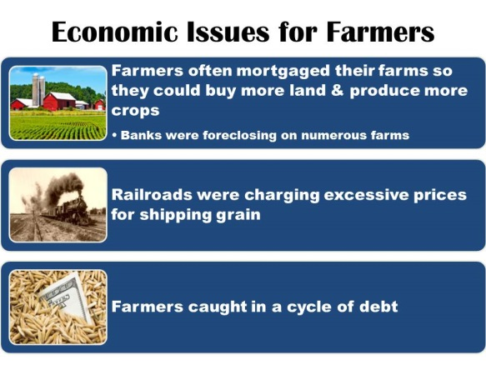
Populist Movement Activity
Economic Issues for Farmers:
- What does it mean that farmers would mortgage their farms? (use your phone to look up the word if needed or ask me)

- Why were farmers caught in a cycle of debt? (use evidence from the chart)

- How do you think that farmers could get out of this debt? (give a solution)

The Grange:
- Grange-

- How did it help out the farmers?

- Why do you suppose they spend so much time fighting the railroads?

Populism:
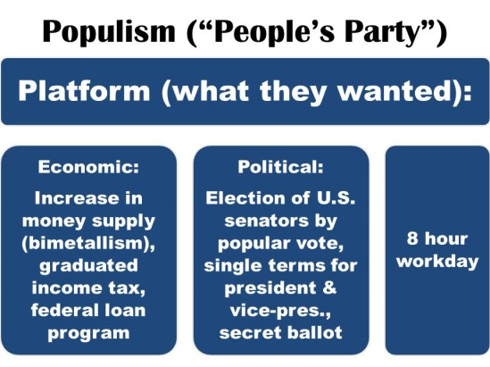
- Why do you suppose they were called the “People’s Party”? (who do you think they appealed to most—read their platform)

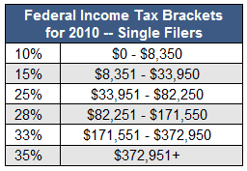
- One of the key aspects of their plan was a graduated income tax. Look at the Federal Income Tax Brackets Chart to the left—this is a graduated income tax.
Based on what you learn from this chart, give a basic definition of a graduated income tax.

- Why do you suppose the Populist wanted the political aspects of their platform?

- Who would an 8 hour workday appeal to the most?
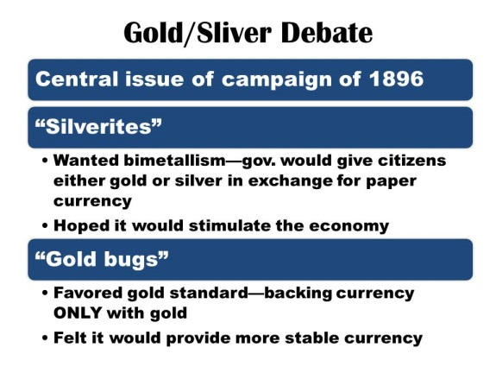
Gold/Silver Debate:
- What was “bimetallism”—what did they want? (ask me if you can’t figure it out from the chart)

- What was a “Gold Bug”?

- If you were living in 1896, which do you think you would have been: Silverite or Gold Bug? Why?

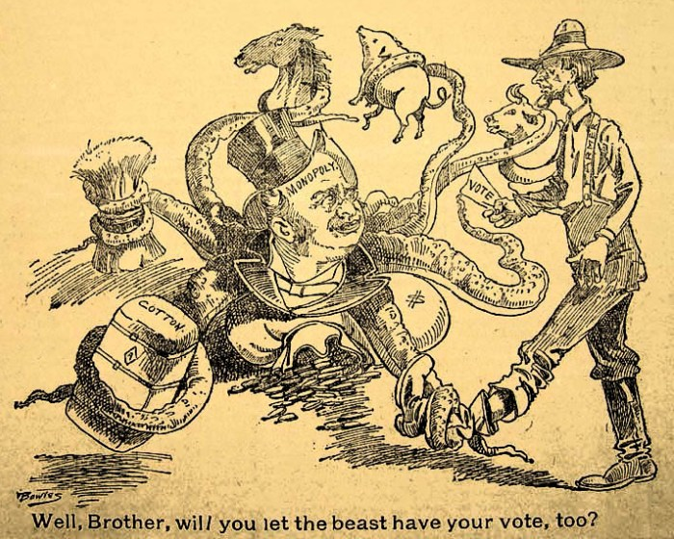
Political Cartoon:
Vote
Monopoly
Cotton
- What animal is “Monopoly”? Why do you suppose the cartoonist
drew this animal to represent monopoly? (you need to know what
a monopoly is first—look it up on your phone if you need to)

- Read the caption at the bottom. What is the farmer
about to do?

- What is the message of this cartoon?

Election of 1896:
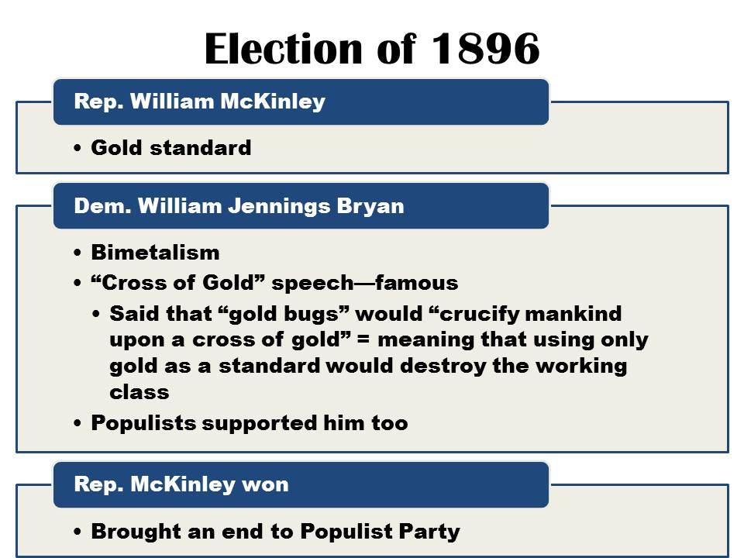
- Republican candidate McKinley was for staying on the gold standard. Who do you think might be typical people that would vote for him because of this? (who would it benefit)

- Democrat candidate ______________________ (name) ran on bimetallism. What was his famous “_________________________” speech about?

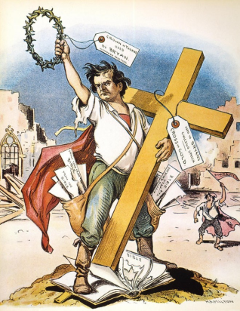
- Why do you think McKinley won the election? (think about who would have supported him)

Political Cartoon
- ________________________ is holding the gold cross in the cartoon. (use info. From above)
- What do the crown of thrones and the cross refer too? (ask me if you are not sure)

- Do you think Bryan sees himself as a savior of the working class? Explain.

“You shall not press down upon the brow of labor this crown of thorns, you shall not crucify mankind upon a cross of gold.” –William Jennings Bryan, Democratic Convention, 1896

Wizard of Oz—Allegory for the Populist Party
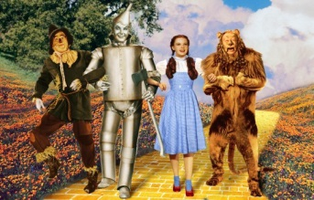
The book/movie the Wizard of Oz is an allegory representing the Populist Party movement. See if you can figure out what each of the following mean. I have given you the answer for the first one.
- Dorothy = “Miss Everyman”; American people at their best: Independent, resourceful, kindhearted, honest all-American girl from the heartland
- Cyclone =
- Yellow Brick Road =
- Silver Shoes =
- Wizard =
- Scarecrow =
- Tinman =
- Cowardly lion =
- Wicked Witches of East & West =
- Good Witches of North & South =

