World War II Map

Use colored pencils ONLY!!! No markers!!

Use the map on page 918 and to complete the assignment.

Color and LABEL the Allied Nations one color:
United Kingdom Soviet Union

Color and LABEL the Axis Nations a different color:
Germany Italy Hungary Romania
Austria Czechoslovakia

Color the water blue!!!

Make a key.

Name ______________________________________

World War II—Europe Map
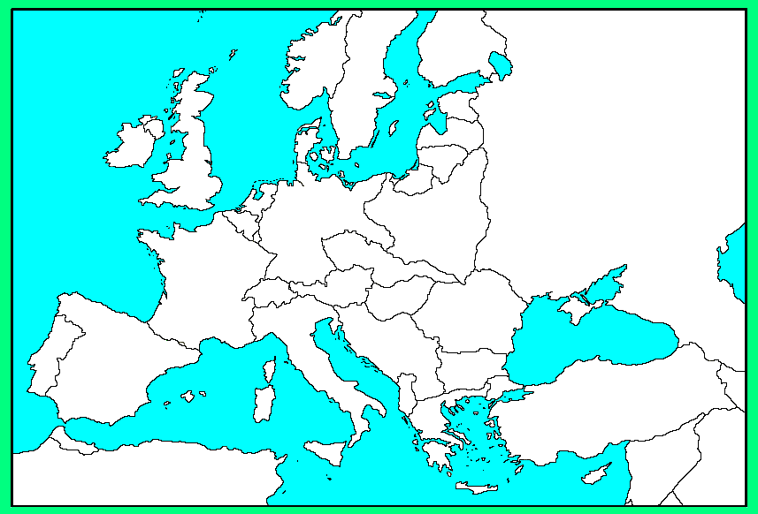
Key:

