Nam e _______________________________________________
Map Activity- Byzantine and Western Europe

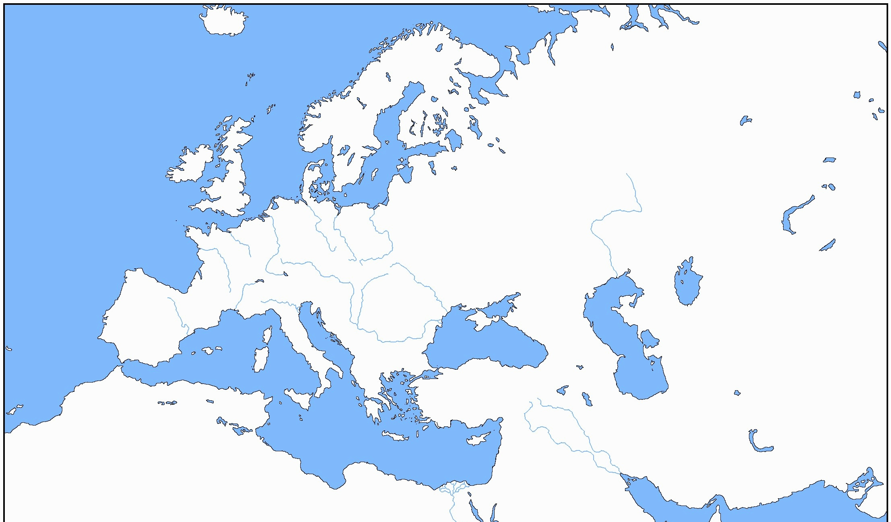
Directions: Complete the following items. Use colors on your map to make the regions easier to identify. Use the following pages in your text: 208, 212, 228, and 235 (and the map on my website).

Map Directions: Use the map on my website to do the following.
- Color AND label the Byzantine Empire.

- Color AND label the following states:
Holy Roman Empire Spain (Castile, Aragon) France Papal States
Kingdom of Sicily Poland Denmark England
Scotland Serbia Hungary Bulgaria

- Find and label the cities of:
Rome London Paris
Use the maps in your textbook for the following cities:
Constantinople Madrid Jerusalem Alexandria Carthage
- Find and label the following bodies of water and color them blue:
Mediterranean Sea Black Sea Red Sea Baltic Sea North Sea

Map Questions:
- Using the maps on pages, 208 and 212: What happened to the control of the Byzantine Empire?

- Using the maps on pages 117 and 228: What happened to the map of Western Europe from the time of the fall of Rome to the time of the Middle Ages around 1360? Make observations and include evidence.

- Using the visuals on pages 207, 209, and 211, describe the major aspects and subject matter of Byzantine art? BE SPECIFIC. According to the caption of page 211, how does Byzantine style art differ from Western European style art?

- Using the map on page 235:
Identify the MAJOR trading ports in EUROPE during this time.

Describe the major trade regions of each of the following- Hansa, Venice, and Genoa commercial routes.

