Industrial Revolution Primary Sources for Socratic Seminar

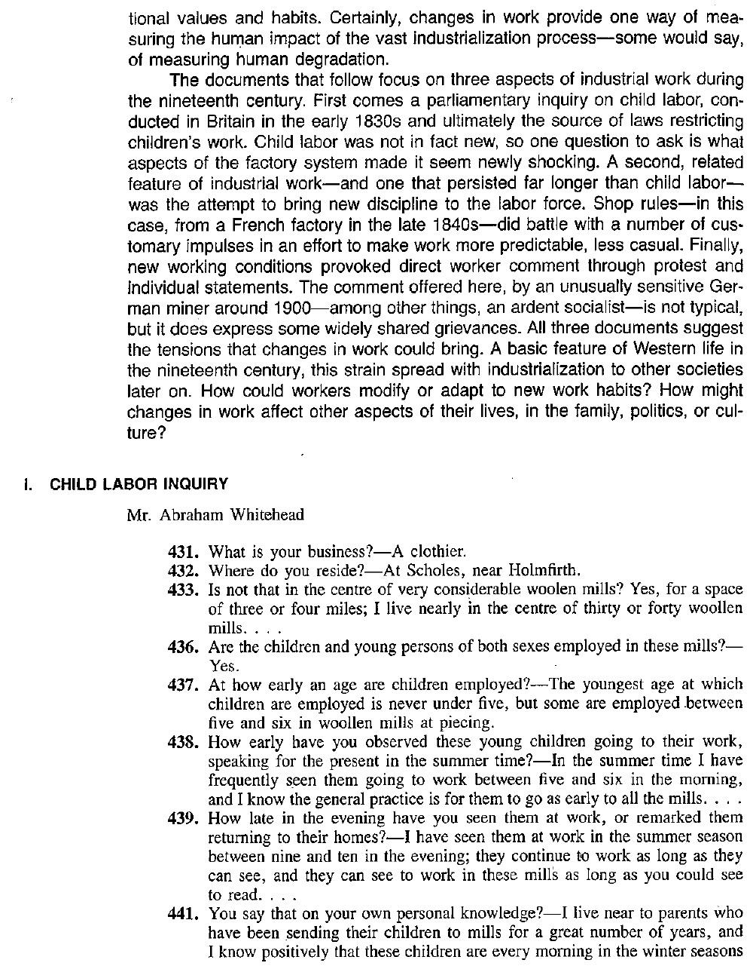

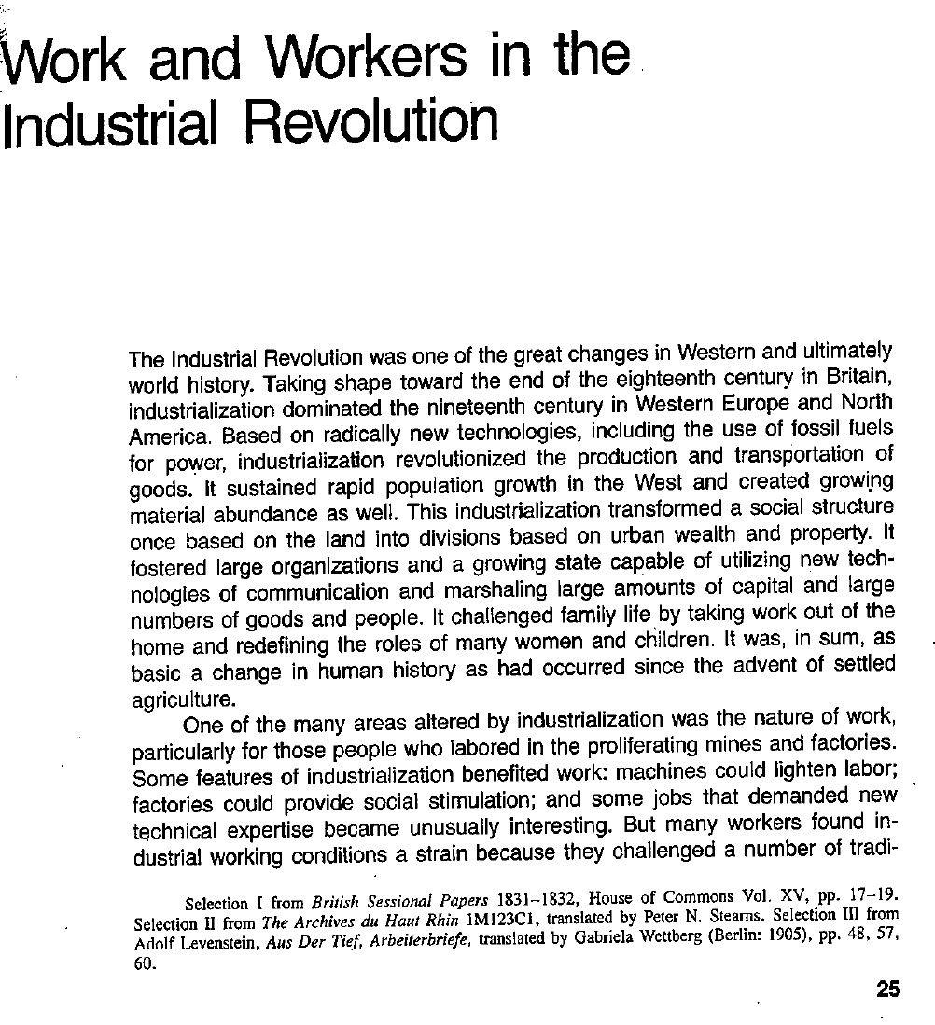

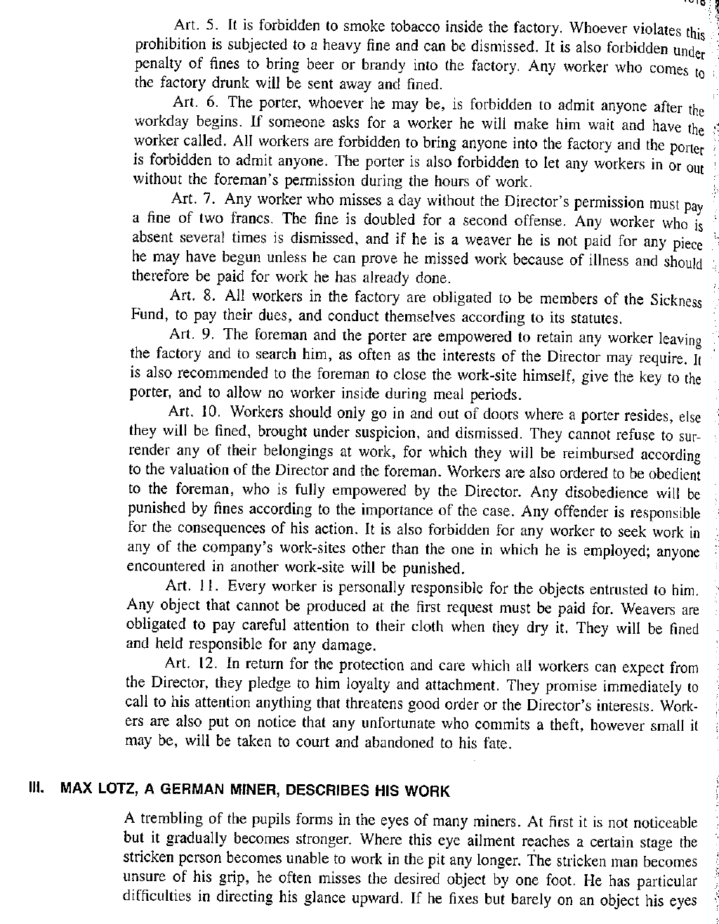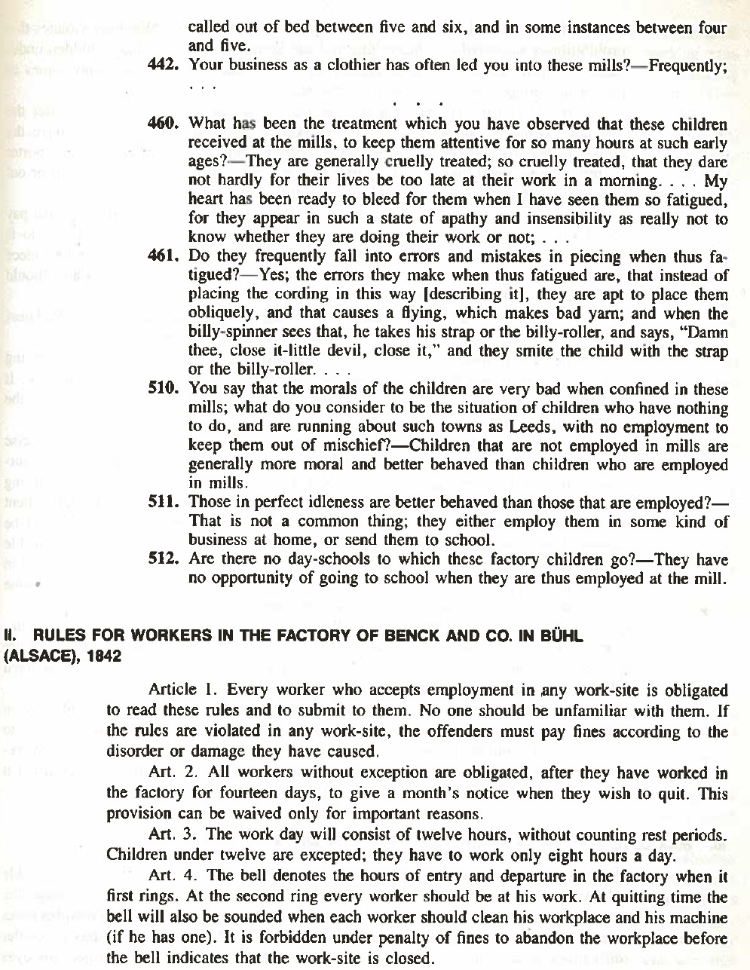

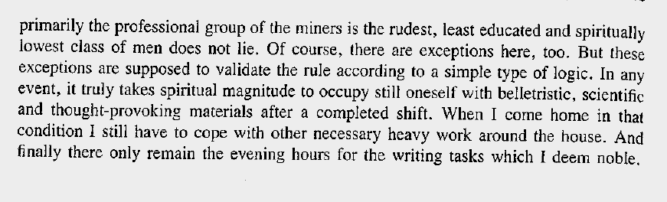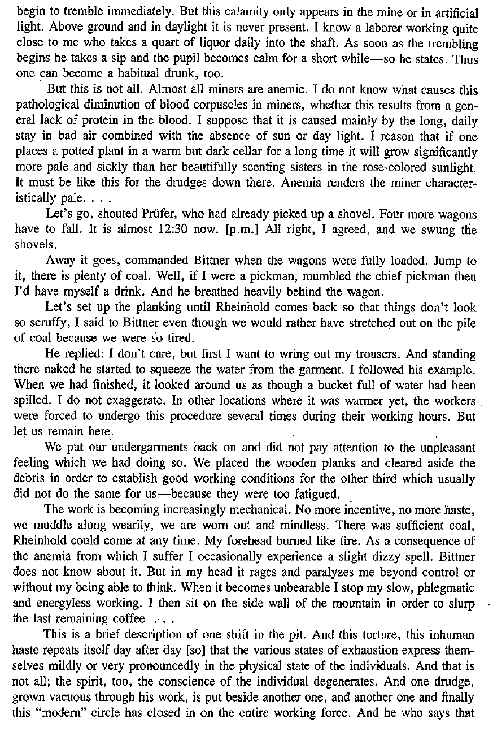

Excerpt from:

Stearns, Peter N. *Documents in World History*. Vol. II, New York, Harper & Row, 1988. II vols.