Name ___________________________________
Roman Empire Map Homework
Roman Trade Map: From all corners of the Roman Empire and from lands beyond the empire came a wide variety of goods to the city of Rome. Foods, spices, jewels, silk, wild animals, minerals, and other products arrived from north, south, east and west. Use the map to answer the questions below.
- List ALL of the areas from which the following products originated.

________________________________ salt
________________________________ silk
________________________________ iron
_______________________________ diamonds
________________________________ amber
________________________________ tigers
________________________________ jewels
________________________________ tin
________________________________ pepper
________________________________ gold
________________________________ leather
________________________________ grain
________________________________ slaves
________________________________ fruit
________________________________ ivory
________________________________ elephants
________________________________ cheese
________________________________ wool
________________________________ paper
________________________________ perfume

- Why do you think Romans wanted these goods from distant lands?

- For what reasons do you suppose slaves and wild beasts were imported from Africa?

- In ancient times, there was a saying that “all roads lead to Rome.” What do you think this meant?

Growth of the Roman Empire Map: Over the course of several centuries, Rome changed from being a small town in Italy to being the center or a vast empire surrounding the Mediterranean Sea. It took hundreds of years and dozens of wars for this to occur. This map highlights the period of Roman expansion.
- _________________________ What man added land between Italy and Britain to Rome’s territory?
- _________________________ France was known by what name during the period?
- _____________ Was Julius Caesar an emperor? (yes or no) (read the dates on the map carefully to get the answer)
- _________________________ Julius Caesar conquered Gaul during these years.
- _________________________ Which lands came under Roman control first—Macedonia and Greece OR Dacia and Mesopotamia?
- _________________________ During the early years of Roman expansion, which city was the only rival of Rome for power in the Mediterranean?
- _________________________ What outstanding general did Rome defeat during the Punic Wars?
- _________________________ During what was series of wars did Spain and North Africa fall under Roman control?
- _________________________ Who was the first of the 65 emperors to rule the Roman Empire?
- _________________________ What emperor added 2 territories, one located north of Macedonia (look for it) and the other east of Syria?
- ________________________ What name was given to the period of peace and prosperity which lasted 2 centuries?
- _________________________ Which city in the eastern Mediterranean opposed Roman rule and was destroyed by the Romans?
- _________________________ Did “Pax Romana” occur in BCE, CE, or both?
- _________________________ Which city was the capital of the Eastern Roman Empire?

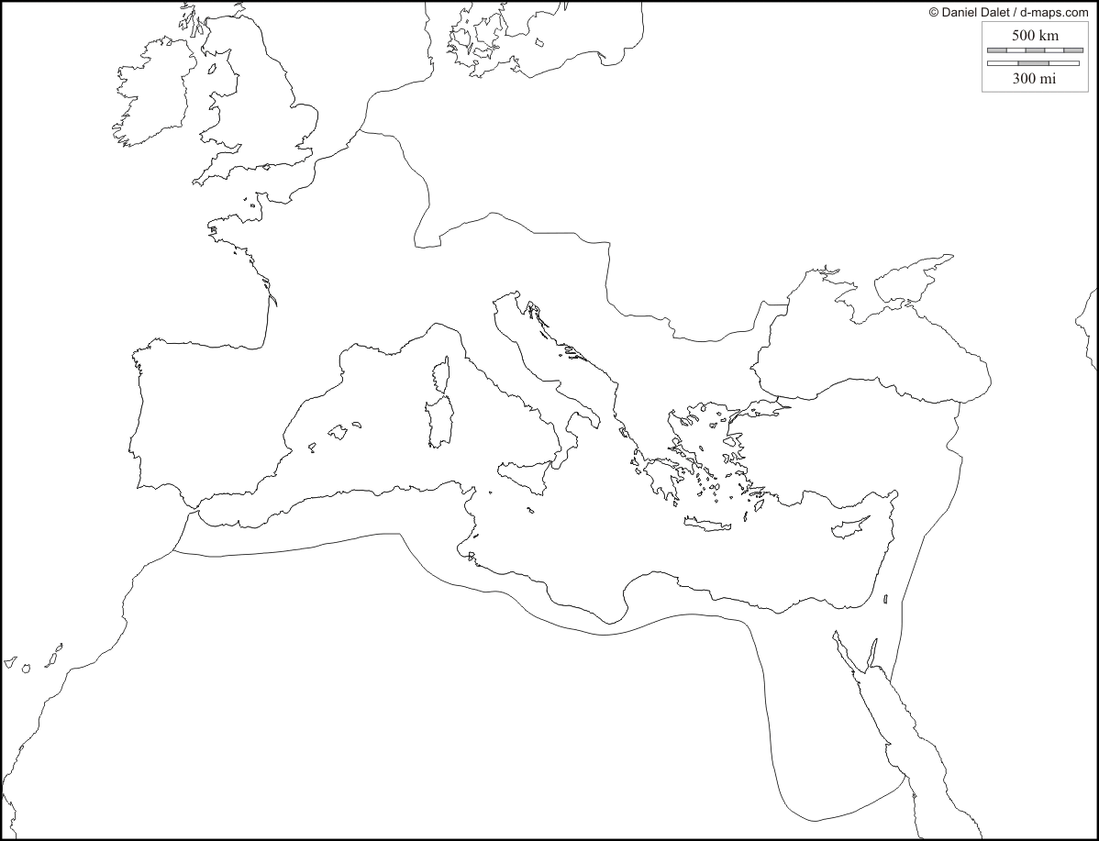
Roman Trade Map
Rome
India
Diamond, pepper, tigers, elephant, jewels
China
Silk, porcelain
Syria, Israel, Arabia
Leather, perfume, timber
Egypt
Grain, glass, paper, linen
Africa
Elephant, tigers, lions, ivory, gold, slaves
Asia Minor
Figs, pomegranates, perfume, cedar, spices, carpets, jewels
Germany
amber
Gaul
Glass, wool, ham, cheese
Spain
Silver, wheat, copper, mercury, cork, gold, tin, fruit, salt
Britain
Iron, hides, tin
Growth of the Roman Empire
Rome
Mesopotamia
Constantinople
395 CE
Because of its great size, the empire was divided into 2 parts, each having its own emperor. Rome was the center of the western capital and Constantinople the eastern capital.
264-146 BCE
Romans fought 3 wars against Carthage. Rome nearly lost the second war due to the brilliant commander Hannibal. At the end of the Punic Wars, Carthage was burned to the ground. Rome took control of Spain and North Africa.
70 CE
Following a Jewish revolt, Jerusalem was destroyed by the Romans. Earlier, Jesus Christ had been put to death, but his teachings began to spread. This led to centuries of Christian persecution. But, gradually Christianity won acceptance and, in the late 300s, became the main religion of the Roman Empire.
107-115 CE
The emperor Trajan added Dacia and Mesopotamia to the empire.
251-146 BCE
Syria, Macedonia, and Greece were defeated by Roman armies.
27 BCE
Augustus Caesar became Rome’s first emperor. “Pax Romana” began. It brought 200 years of peace and prosperity.
58-49 BCE
Julius Caesar, in the “Gallic Wars,” captured lands stretching from northern Italy across Gaul (France) to Britain.
North Africa
Jerusalem
Syria
Carthage
Greece
Dacia
Macedonia
Italy
Gaul

