Renaissance Noodle Tools Directions
Part 1: Research
- Using one of the databases from the Library Resource Page (on CCHS website), research a topic on the Renaissance (Use databases such as: ABC-CLIO, Gale, …). (if doing from home- id: creek, password: bear)
- Possible topics to research today: Renaissance art, Renaissance in Florence, Renaissance women, or any of the key Renaissance figures (such as, da Vinci, Petrarch, Thomas More, Machiavelli,…) (only research 1 of these topics today)
- Pick 1 article from a database to use for your research today.

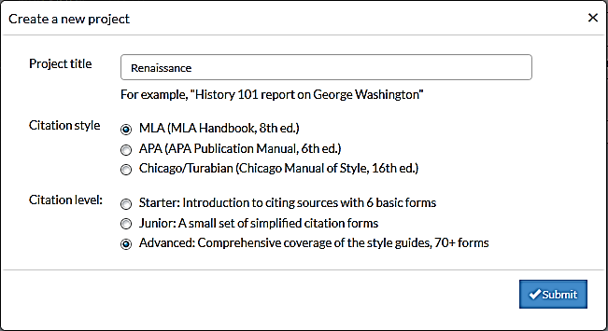
Part 2: Log on to Noodle Tools
- Go to Noodle Tools from the CCHS Library page or type in www.noodletools.com
- Log in (an account has been created for you by the library)
  - Use your Active Directory username & password.
  - Example User name: smitha45
  - Password: your school ID number
- Click “New Project.”
- Title the project “Renaissance.” (choose MLA, and Advanced)

Part 3: Source information
- Click “Sources” at the top.
Your Textbook Source:
- Click “Create New Citation.”
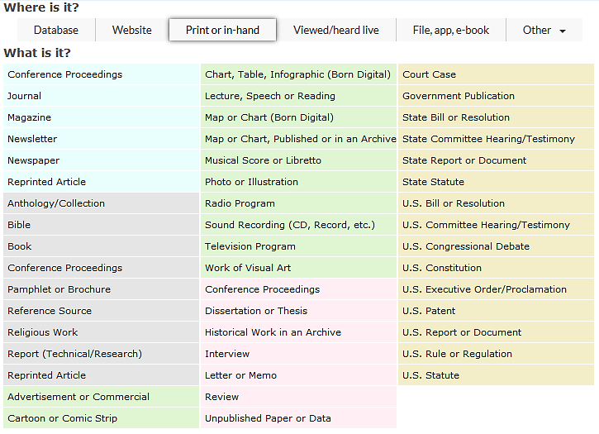
- Click on “Print or in hand.”
- Click “Book”. Enter your textbook’s ISDN . Your textbook should show up as a choice.
- Click on your textbook: A History of World Societies
  - Click “Import selected source”
- Type in the section title: “Europe in the Renaissance and Reformation, 1350-1600”
- Add the page #s: 388-390.
- Scroll down—hit “submit.”

Your Database Source:
- Add another entry—your database source information.
- Click on “Database.”
- Click “Original Content in Database.”
- Click “Copy & Paste Citation.”
- Copy the MLA format information from ABC-CLIO or World History in Context and paste into “Manually-edited citation.”
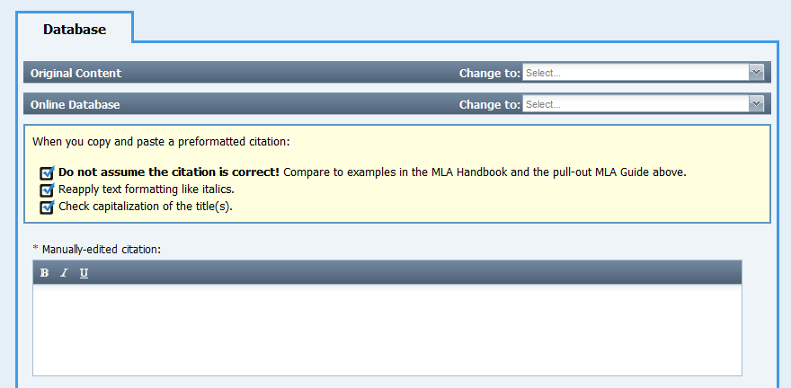
- After you have finished citing the source, click “submit” at the bottom of the page.

Part 4: Creating notes
Next, you are going to create your notes based on this source.
- Click “Notecards” at the top of the screen.
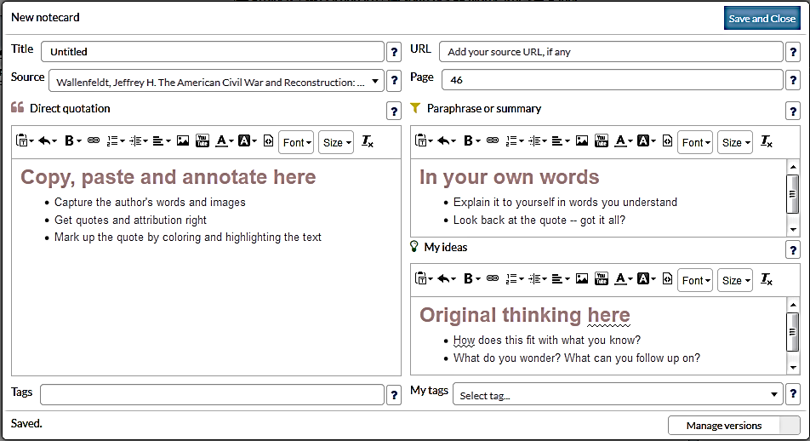
- Click “New.” (Each note you make should be on focused on 1 very specific topic—ex. “Mona Lisa’s significance”)
- Create a Title based on the Information you are going to put on this note. (such as “da Vinci’s art”
- Click on your source. (Do NOT forget to do this! It is important.)
- Quote and/or paraphrase a portion of what you read from your source. (Remember this should be no longer than what could fit on a 3x5 notecard, so it should only be 2-4 sentences long or 2-4 bullet points)
Quote
Paraphrase
- Feel free to use bullet points if you are paraphrasing.
- If it is from your textbook, put the page number.
- Hit “Save and Close”
- Type in your 4 notecards from your “Renaissance Notecards Homework.”
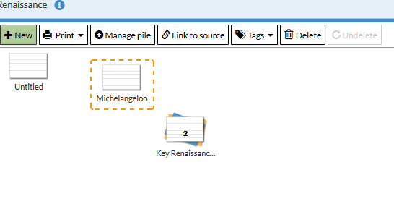
- Add in 2 other notes based on your database source.

Part 5: Creating groups/piles
- Once you have created several notes, you can start creating groups.
- Find 2 notes that relate to the same topic (such as: “da Vinci”).
  - Place one note over the other note—this should group/pile the 2 notes together.
  - Give it a Pile title (such as: “da Vinci” or “key Renaissance Men”)

Turn in by the end of the period:
- Print out your Noodle Tools notes—write your name on the top of the sheet
- How to print: Click “print”
  - Export to “As a Webpage (HTML file)”
  - “Export all notecards”—hit “Submit”
  - Hit ctrl “P”
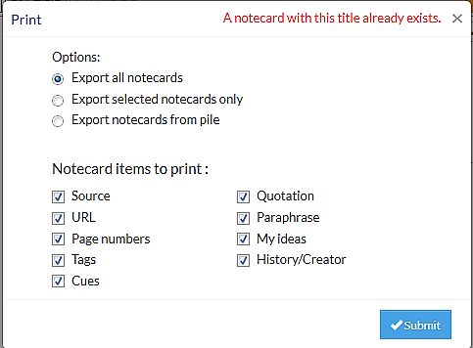
Requirements:
- 2 sources—1 is your textbook and 1 is a database
- 6 notes
- 1 group/pile

