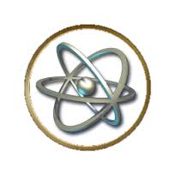
Name _________________________________

The Scientific Revolution
1: Background on Scientific Revolution
- Describe the beliefs about science in Europe during the Middle Ages.

- Geocentric Theory- (what is it? Who’s idea?)

2: The Sparks of the Scientific Revolution
- What major events and eras led up to the Scientific Revolution? How so?

3: The Heliocentric Theory
- Below, take notes on Nicolaus Copernicus and the heliocentry theory. (3-5 bullet points)

- Are there times when an idea is too dangerous to be openly discussed or taught? Explain your answer.

- What did Johannes Kepler believe about the planetary motion?

4: Galileo’s Discoveries
- List 4 of Galieo’s discoveries/inventions (make a note beside those that dispute Aristotle’s beliefs).

5: Conflict with the Church
- Below, take notes on Galileo’s issues and trial in front the Catholic Church. (3-5 bullet points)

- By silencing Galileo, the church wanted to suppress an idea. Do you think this was an effective strategy? Can an idea have a life of its own?

- Galileo faced persecution for teaching new ideas. Could this happen today? Be specific with examples.

6: The Scientific Method
- Describe the scientific method.

- You use this method in your science classes today. Why do you suppose it is still so important?

- Give an example of an time when you recently used the scientific method in science class.

- Discuss Sir Francis Bacon’s impact on the scientific method.

7: Newton Explains the Law of Gravity
- Explain Newtons law of gravity.

- What did he believe about the universe. Describe in detail.

- “If I have seen farther than others,” said Newton, “it is because I have stood on the shoulders of giants.” Who were the giants to whom Newton was referring?

Could this be said of any scientific accomplishment? Explain.
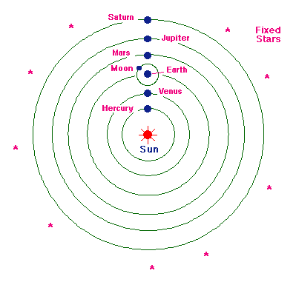

Overview:
- Based on the image on the right, what theory is this supporting? Is there anything wrong with this drawing as it is? (Talk among your group and think of what you know about astronomy from science courses.)

- On the flow map below, fill in the cause/effect of the Scientfic Revolution.
Effect
Cause
Scientifc Revolution

