World History Research Paper
Parenthetical Outline and Works Cited

Outline due: ________________________________

Format Overview for all parts (including cover and works cited):
- Times New Roman, 12 point font (no bigger, no smaller, no different font type)
- Double-spaced
- 1” margins on all sides

Cover Page: (centered—horizontally AND vertically)
- Title—Not just your person’s name—be creative
- Your name
- Picture of your person
- Mrs. Ingles
- World History Period ___
- Date it is due

Outline:
- See example format on my website
- This should be 6-8 pages, typed, double-spaced
If there was no author for the source, put the 1st word on from the works cited—if that word is in quotes, it needs to be documented in quotes as well
- Title (create your own based on your topic)
- Thesis statement (in complete sentences)
- Your detailed outline!!!!! Each fact should be cited
- 1st word of each point should be capitalized
- Cite each of your points on your chart
  - Parenthetical citations = (Last name page number) Example: (Smith 249).

Works Cited Page
- Title it “Works Cited”
- Alphabetical order based on the 1st word of each citation
  - If the 1st word is “the” use the next word for order
  - If more than one source starts with the same 1st word, base the order on the 1st word that is different
- Double-spaced
- Do NOT add an extra lines between each source
- Hanging indent = 1st line of each source should NOT be indented, all lines after that for the source need to be indented (see example)
  - In Google Docs you will need to do this by highlighting all of your documents and then adjusting your rulers. See images below.
Hanging indent
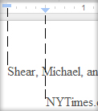
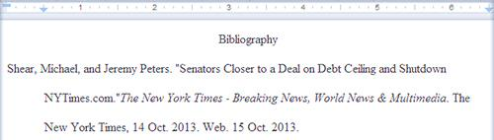
First line
Creative Title
Thesis: (should be 2-4 sentences)
- Background Information (if you have any)
- First point from thesis
- Second point from thesis
- Third point from thesis
- Fourth point from thesis (if you had one)
- Fifth point from thesis (if you had one)
- Analysis (Conclusion)
  - Opposing argument

  - Why your thesis and supporting arguments (points from thesis) are stronger than your opposing argument
Answer just one of these

  - Why is your topic/argument important? (ex. Why is it important that da Vinci was the ultimate Renaissance man?)
  - How might understanding your topic/argument affect the future? (ex. How might understanding that da Vinci was the ultimate Renaissance man affect the future/today?)

