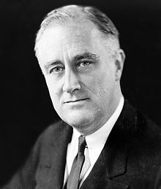
Franklin Roosevelt’s first inaugural address, 1933
This great Nation will endure, as it has endured, will revive and will prosper.
So, first of all, let me assert my firm belief that the only thing we have to fear is fear itself—nameless, unreasoning, unjustified terror which paralyzes needed efforts to convert retreat into advance. In every dark hour of our national life, a leadership of frankness and of vigor has met with that understanding and support of the people themselves, which is essential to victory. And I am convinced that you will again give that support to leadership in these critical days.
In such a spirit on my part and on yours we face our common difficulties. They concern, thank God, only material things. Values have shrunk to fantastic levels; taxes have risen; our ability to pay has fallen; government of all kinds is faced by serious curtailment of income; the means of exchange are frozen in the currents of trade; the withered leaves of industrial enterprise lie on every side; farmers find no markets for their produce; and the savings of many years in thousands of families are gone. More important, a host of unemployed citizens face the grim problem of existence, and an equally great number toil with little return. Only a foolish optimist can deny the dark realities of the moment.
And yet our distress comes from no failure of substance. We are stricken by no plague of locusts. Compared with the perils which our forefathers conquered, because they believed and were not afraid, we have still much to be thankful for. Nature still offers her bounty and human efforts have multiplied it. Plenty is at our doorstep, but a generous use of it languishes in the very sight of the supply…
Yes, the money changers have fled from their high seats in the temple of our civilization. We may now restore that temple to the ancient truths. The measure of that restoration lies in the extent to which we apply social values more noble than mere monetary profit.
Happiness lies not in the mere possession of money; it lies in the joy of achievement, in the thrill of creative effort. The joy, the moral stimulation of work no longer must be forgotten in the mad chase of evanescent profits. These dark days, my friends, will be worth all they cost us if they teach us that our true destiny is not to be ministered unto but to minister to ourselves, to our fellow men.

Herbert Hoover’s acceptance speech for the
Republican nomination to the presidency in 1932
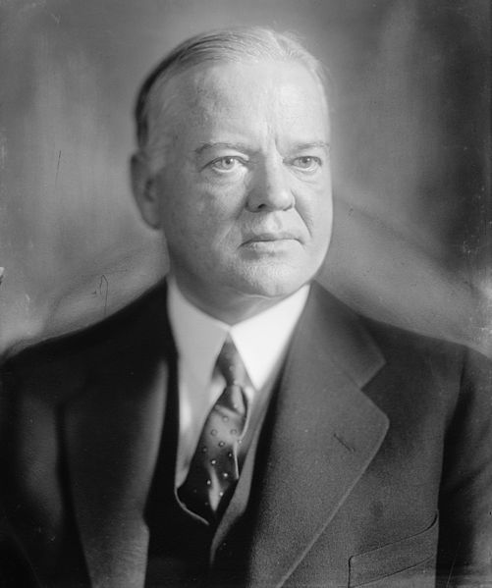
If it shall appear that while I have had the honor of the Presidency I have contributed the part required from this high office to bringing the Republic through this dark night, and if in my administration we shall see the break of dawn to a better day, I shall have done my part in the world. No man can have a greater honor than that.
I have but one desire: that is, to see my country again on the road to prosperity which shall be more sane and lasting through the lesson of experience, to see the principles and ideals of the American people perpetuated.
I rest the case of the Republican Party on the intelligence and the just discernment of the American people. Should my countrymen again place upon me the responsibilities of this high office, I shall carry forward the work of reconstruction. I shall hope long before another four years have passed to see the world prosperous and at peace and every American home again in the sunshine of genuine progress and genuine prosperity. I shall seek to maintain untarnished and unweakened those fundamental traditions and principles upon which our nation was founded and upon which it has grown. I shall invite and welcome the help of every man and woman in the preservation of the United States for the happiness of its people. This is my pledge to the nation and to Almighty God.

