Mayan Archelogy Activity
Mayan Map

This is a map of the Maya country, broken down into three environmental regions: the Northern Lowlands, the Southern Lowlands, and the Highlands. The lowlands are characterized by thick limestone bedrock that absorbs much of the rainfall that falls there. The Highlands are mountainous with some volcanoes.
The Northern Lowlands are dry and desert-like with thorny shrub-like forests.
The Southern Lowlands receive high rainfall and are covered in a tropical rainforest.
The Highlands are covered in a lush forest and receive lots of rain.
- The solid lines represent borders between different countries. Fill in the names of these countries on the map: Mexico, Guatemala, Belize, and Honduras.
- The dotted lines represent the environmental regions. Color each environmental region of the map a different color.
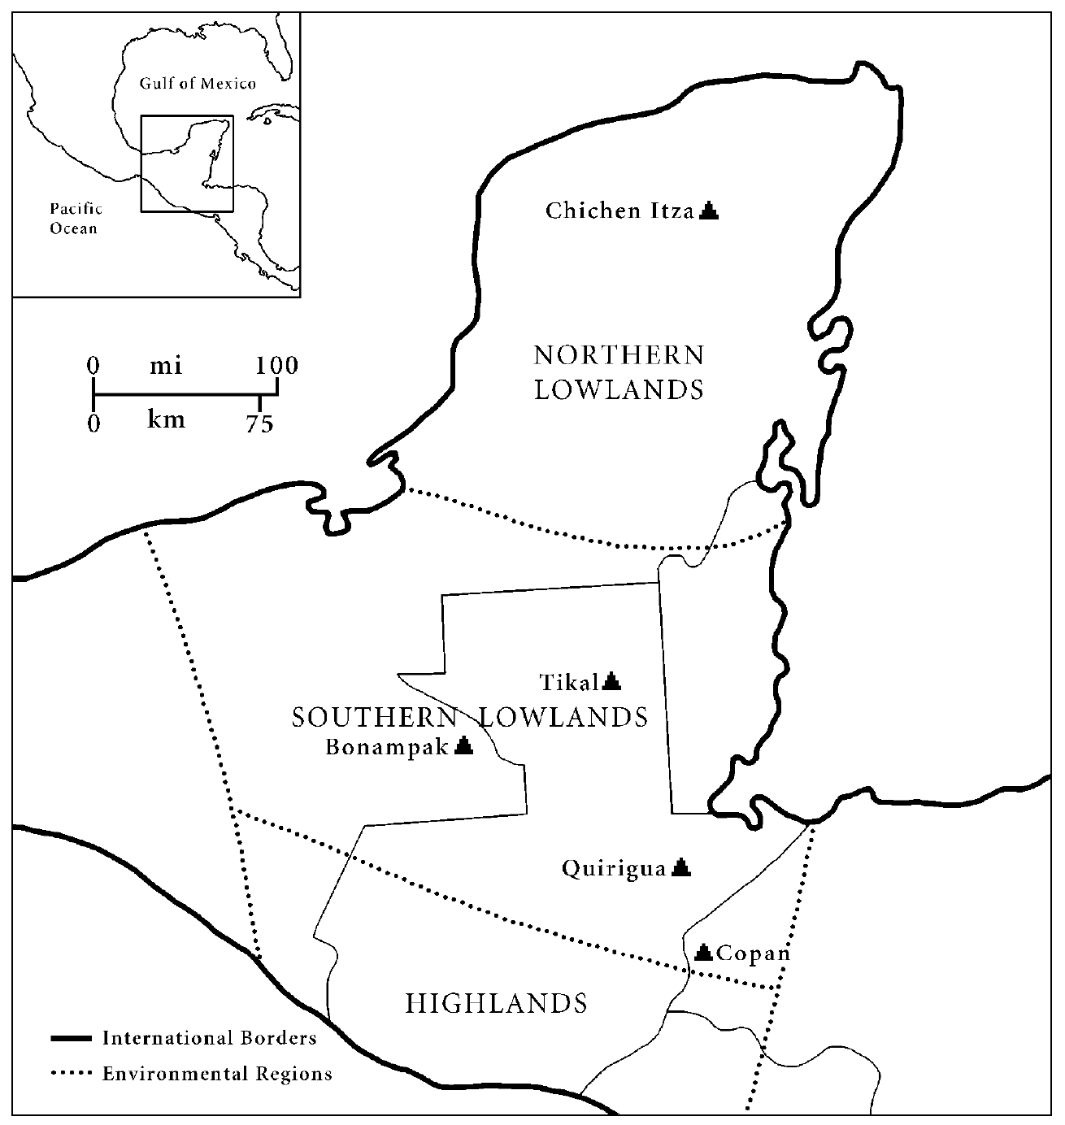

Mayan Collapse Theories
Read each theory and take notes. Then answer the conclusion questions.

- Theory 1: Drought
  - Your Notes

  - Conclusion
Do you think the drought theory is correct and that a prolonged dry climate was enough to make the
Classic Maya collapse?
Do you think people could have adapted to the dry climate?
Explain.

- Theory 2: Agriculture
  - Your Notes

  - Conclusion
If you were an archaeologist who studied the skeletal remains of a large portion of the Classic Maya population, and you found that many of them were diseased or malnourished, would you support the agricultural theory for collapse? Explain.

- Theory 3: Warfare
  - Your Notes

  - Conclusion
Do you think this theory is correct? Explain why or why not.

Mayan Archelogy
Post-Activity Conclusions
The examples of archaeological evidence you have just finished analyzing are just three pieces of a very large puzzle that archaeologists try to piece together to understand the complex events that led to the Maya collapse. Notice that different types of evidence are needed to test each theory.
Now, think of ONE additional piece of archaeological evidence to look for in support of each theory:
Theory 1._____________________________________________________________
Theory 2._____________________________________________________________
Theory 3._____________________________________________________________
Which theory looks the strongest? Which looks the weakest? Explain.

Can you think of any evidence that might contradict or disprove any of these theories? Explain.

Conclusion
- Write an introduction paragraph below based on your findings and conclusions (with CONTEXTUALIZATION AND THESIS). (Use at least 3 main points on the CAUSES of the collapse of the Mayan. Remember, this is the like the introduction to a causation LEQ.)

