Asian Gunpowder Empires Activity
Ming Dynasty (China)

Ming Exploration
- Why did the Ming decide to send out voyages?

- Describe Zheng He’s 7 voyages.

- As a result of his voyages, 16 nations started paying tribute to Ming China. What does that mean? (use your phone to look up the word tribute if you need to)

- What happened after his 7th voyage?

- Look at the map. What is the furthest Zheng He travelled?

- Based on the chart, compare the voyages of Zheng He with the Europeans. What do you notice?

Qing Dynasty Begins
- What were the problems with the Ming Dynasty that caused its decline?

- Who takes over in 1644? _________________Why was this significant?

- What things did they do that the Chinese people liked?

- What was a queue?

- Examine the map. What territories do the Qing take over?

Foreigners in China
- What rules must foreigners follow if they wanted to trade with China?

- How did the Dutch react to these trading rules with China?

The British?

- Explain Matteo Ricci.

Tokugawa Shogunate (Japan)
- Explain Tokugawa Ieyasu’s rise to power.

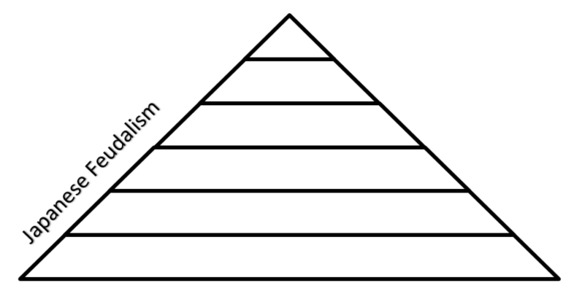

European Influence in Japan
- Describe what the Portuguese brought with them when they came to Japan.

How did the Japanese respond to this?

- Did Christian, Catholic missionaries have success in Japan? Explain.

- How did the shogun respond to these missionaries?

