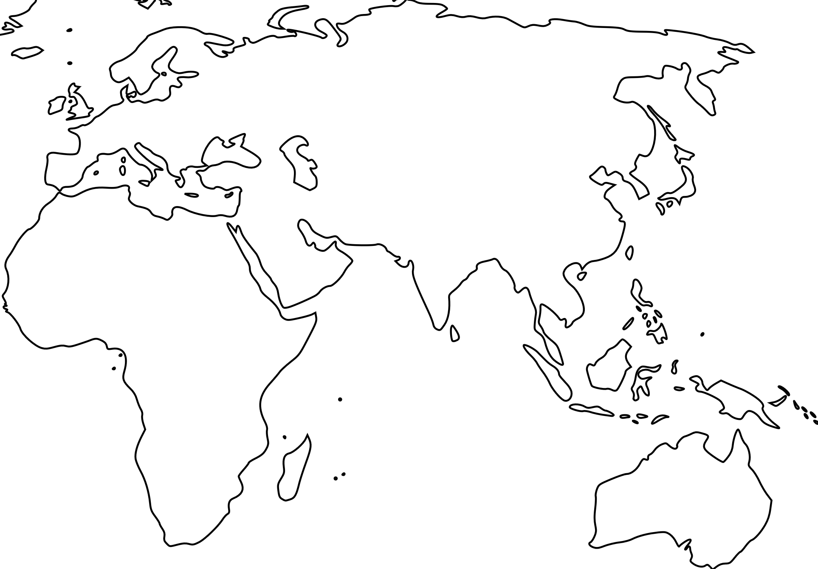

**Afro-Eurasian Trade Routes:**

**Amazing Race**

Key:

Silk Roads

Hindu Influence

Buddhist Influence

Islamic Influence

Indian Ocean Trade Routes

Monsoon Winds

Trans Saharan Trade Route