Name ____________________________________________________________________
Mayan and Aztec Activity
Images
- Based upon the image below, what do you suppose the Mayans used this location for?

- What do think the image below is of? Why do you think it was significant to the Mayans?

- What do you think is the significance this image?

- What do you think is the significance of the rope below?

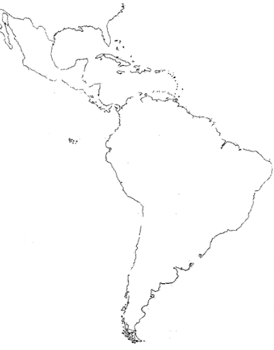
Map

1: Mayans: Cities, Trade
- What was Chichen Itza?

- There were over _____ (#) city-states ruled by a __________________ and serving as a center for ____________ ceremonies and trade. So, in essence, the Maya was not a unified empire.
Which other civilization that we studied this year are the Mayan similar to in this aspect?

- How were the city-states linked to each other?

- Did the Mayan have a form of money?

2: Mayan Advances
- Explain the major Mayan advances:
Writing-
Math-
Astronomy-

Calendar-

3: Mayan Religion
- Describe the Mayan gods.
- How did they worship their gods.

- Describe the Mayan use of human sacrifice.

4: Mayan Decline
- What occurred in the late 800s?

- What are some theories experts have about why the Maya declined?

5: Aztec Foundations
- How did the Aztecs find their capital city?

- By the early 1500s, the empire had an estimated population between __ and ___ million people.
6: Tenochtitlan
- At its height, it had a population of _____________________.
- Describe the city.

7: Aztec Government
- Did the Aztecs have a centralized form of government? _____
Was it strong? _____
- How did they treated the emperor?

- Describe their military conquest.

- How did the Aztecs respond to resistance?

8: Aztec Religion
- The Aztecs worshiped ____ deities.
- What was the significance of Huitzilopochtli?

- What did they believe about Quetzalcoatl?

- Describe the Aztecs belief in human sacrifice?

- Why did they sacrifice so many? (hint: think about who they were mainly making the sacrifice to. Ask me if you need help)

9: Aztec Decline
- Explain the significance of Montezuma II.

- Why do you think that much of the provinces that had been conquered by the Aztecs opposed him?

- What did the Aztecs believe about Cortes?

How might this work in the favor of the Spanish?

- Look at the number of Spanish that came. How did such a small number of Spanish conquer the Aztecs (there are millions of them)?

- Who aided the Spanish?
Do you think this was a good idea for them? Why?

- How did disease impact the Aztecs?

10: Images, Primary Sources
- Document 1: Describe the significance of Mayan architecture evidenced in this temple at Tikal (in Guatemala)?

- Document 2: Why was Cortés impressed when he arrived in Tenochtitlán in 1519?

This is actually a letter written by Cortés to the Spanish King, Charles V. How does that information impact what he wrote in the document? (think about point of view—ask me if you need help)

- Document 3: The Maya number system was based on 20. Shells, dots and bars were combined to represent numbers. Using this chart, how would you represent number 25 in this system?

- Document 4: look at the image and view the video about the Aztec chinampas. What were they used for?

Why do you suppose the Aztecs needed them (consider the city of Tenochtitlan)

