The Great Depression
The Great Depression was a global economic crisis that started in 1929. The crisis devastated the economies of many nations and led to a period of financial hardship for millions of people.
In the history of the United States, no other depression had had such a devastating impact on U.S. society. During the 12 years of the depression, one-quarter of the work force was unemployed, 5,500 banks closed, and 32,000 businesses went bankrupt.
Although the crash of the New York Stock Exchange on October 29, 1929 was a symptom rather than a cause of the depression, it has been blamed as the catalyst. The depression in fact resulted from an overextension of credit and spending in the 1920s. Nonetheless, the stock market crash dramatically shook public confidence in the U.S. economy.
The crash also brought an end to the loans that the United States had extended to European countries, which were still recovering from World War I. Europe slipped further into decline and lost any economic gains made in the 10 years since the end of the war.
The economies of many Latin American and Asian countries, organized around the export of primary products to the industrial markets of the North Atlantic world, quickly collapsed in response to the loss of their markets. The global crisis was exacerbated by the tendency of most nations to erect tariff barriers in an attempt to protect domestic economies. As international trade ground to a halt, there was no way to alleviate the situation.
The Great Depression produced political crises in many of the nations that were hardest hit. In Latin America, for example, several governments fell between 1929 and 1931; democracies were replaced by authoritarian regimes, and dictatorships were overthrown by democratic forces. In Europe, the hardships of the depression inspired a variety of extremist political groups. The desperate economic situation of the German Weimar Republic was an important condition for the rise of fascism in the later 1930s.
In the United States, threats to the stability of the U.S. government and economy were dispelled by the "New Deal" programs devised by the administration of President Franklin D. Roosevelt.

"Great Depression." American History. ABC-CLIO, 2013. Web. 10 Feb. 2013.

Stock Market Crash
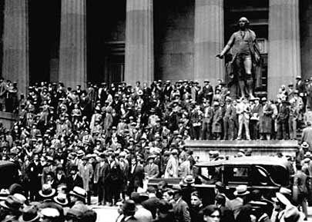
Black Thursday, October 24, 1929, was the first day of real panic during the stock market crash of 1929. It initiated a series of stock market panics, the most dramatic of which was on October 29 [Black Tuesday], when the losses on the stock market plunged the country into a deep depression.
After experiencing tremendous growth in the 1920s, the stock market began to be sluggish in September and early October 1929 as trading slowed ominously. On October 18, stock prices fell precipitately, which alarmed many investors although overall confidence in the market remained high.
On the morning of Thursday, October 24, however, nervous investors began selling their stocks off quickly, thus triggering a further fall in stock prices that sent the stock market heading for a crash. The day quickly became known as Black Thursday and marked the first day of real panic regarding the soundness of the market. A record 12,894,650 shares of stock were traded as many investors tried to unload their stock—regardless of the price—in an attempt to cut their losses. The stock market was saved from crashing, however, when many major banks and investment companies bought large blocks of stock and successfully stemmed the panic.
The street scene on Wall Street in front of Federal Hall on October 24, 1929
The following Monday, the panic began again, and on the day after that (Black Tuesday), prices on the stock market collapsed completely after 16 million shares were traded. Although the stock market crash of 1929 did not alone cause the Great Depression, a 10-year economic downturn that affected all western industrialized nations, it definitely contributed to it.

"Black Thursday." American History. ABC-CLIO, 2013. Web. 10 Feb. 2013.

Dust Bowl

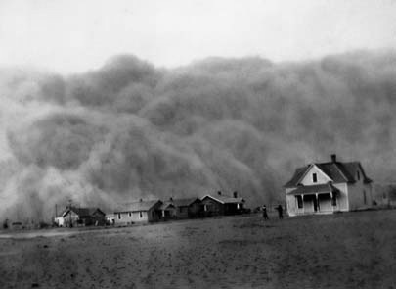
A 150,000-square-mile area in the panhandles of Texas and Oklahoma and portions of Colorado, Kansas, and New Mexico, the Dust Bowl was the scene of an agricultural nightmare in the mid-1930s. It caused considerable economic dislocation for the Midwest and parts of the South.
The heavily farmed area was struck by a severe drought and high winds in the summers from 1934 to 1937. Those conditions caused the topsoil to blow into great clouds of dust. The dust clouds obscured sunlight, piled up in drifts as high as snow, and devastated agriculture and livestock in the region. By 1935, the severe drought had caused the Dust Bowl area to expand over much of the Great Plains.
For many farmers who were already suffering the effects of the Great Depression, the dust clouds were the final blow. They sold or abandoned their land and moved west to California to start over.
The federal government recognized that the primary cause of the dust clouds was agricultural overproduction that had stripped the land of the natural grasses necessary to anchor the topsoil. Congress established the Soil Conservation Service in 1935 to work with farmers to conserve their land. The federal government also bought 11.3 million acres of overused land to keep it out of production.

"Dust Bowl." American History. ABC-CLIO, 2013. Web. 10 Feb. 2013.

The Great Depression’s Effect on Society

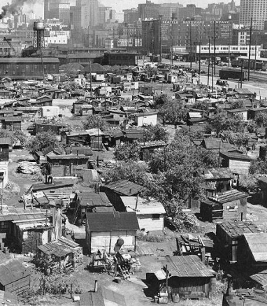
In cities across the country, people lost their jobs, were evicted from their homes and ended up on the streets. Some slept in parks or sewer pipes, wrapping themselves in newspapers to fend off the cold. Others built makeshift shacks out of scrap materials. Before long, numerous shantytowns (also known as “Hoovervilles”)—little towns consisting of shacks—sprang up.
Every day the poor dug through garbage cans or begged. Soup kitchens offering free or low-cost food and bread lines, or lines of people waiting to receive food provided by charitable organizations or public agencies, became a common sight.
Conditions for African Americans and Latinos were especially difficult. Their unemployment rates were higher and they were the lowest paid. They also dealt with increasing racial violence from unemployed whites competing for the same jobs.
In the face of the suffering of the Great Depression, the family stood as a source of strength for most Americans. In general, Americans believed in traditional values and emphasized the importance of family unity. At a time when money was tight, many families entertained themselves by staying at home and playing board games, such as Monopoly (invented in 1933), and listening to the radio.
Many men had difficulty coping with unemployment because they were accustomed to working and supporting their families. Every day, they would set out to walk the streets in search of jobs. Some men became so discouraged that they simply stopped trying. Some even abandoned their families. During the Great Depression, as many as 300,000 transients—or “hoboes” as they were called—wandered the country, hitching rids on railroad boxcars and sleeping under bridges.
Many teenagers looked for a way out of their suffering. Hundreds of thousands of teenage boys and some girls hopped aboard America’s freight trains to zigzag the country in search of work, adventure, and an escape from poverty. These “wild boys” came from every section of the United States, from every corner of society. “Hoover tourists,” as they were called, were eager to tour America for free.

Danzer, Gerald A. The Americans: Reconstruction to the 21st Century. Evanston, IL: McDougal Littell, 2005. Print.

